年 班 座號： 姓名：
高雄市立陽明國中99學年度第1學期第1次段考一年級英語科試題
※背面有試題※
一英語1
I、聽力測驗：16％
A.根據錄音內容，與圖片相符合的寫T，不符合寫F 。6％
(1)  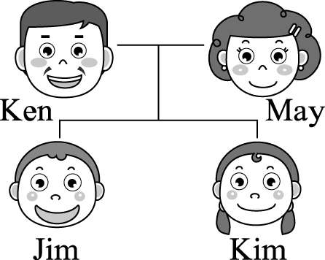  ( ) | (2)  Mr. Hanks Mrs. Hanks    ( ) | (3)  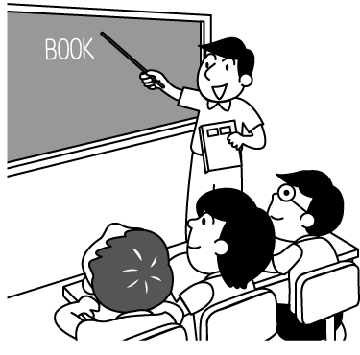  ( )
(4)  3892919  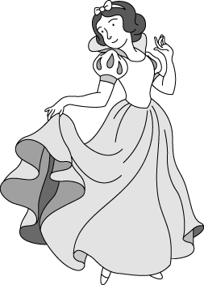  ( ) | (5)  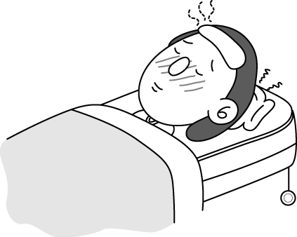  ( ) | (6)  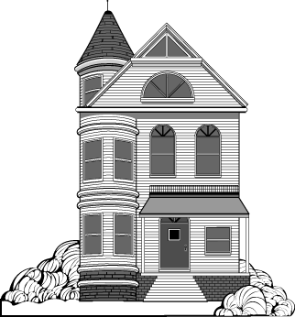  ( )
B.根據錄音內容，選出適當的答句。10％
1. (A) She is a student. (B) She is my sister. (C) She is a beautiful cat. (D) He is my friend.
2. (A) How are you? (B) I am nice, too. (C) Nice to meet you, too. (D) Really? You are so nice.
3. (A) Wow! It’s so cool! (B) Yes, it’s a new car. (C) Thank you. I like it. (D) It’s a bike.
4. (A) She is only ten. (B) Very well. Thank you. (C) She is my grandma. (D) I’m so happy to have a grandma.
5. (A) No, she is very good. (B) She is my cook. (C) Yes, and she’s a good mom. (D) Yes, he is a good cook.
II、印刷體大小寫字母互換：10％
- afraid 2. unique 3. FAVORITE 4. BUILDING 5. EMPHASIZE
III、字彙測驗：20％
1. My g_____r has three sons, my father, Uncle Joe and Uncle Bill.
2. My mom is a great(很棒的) h________e. And she can cook delicions(美味的) food(食物) for me.
3. Nineteen and twenty-one is f______y.
4. That boy s_______t is Justin Bieber. He is in my class.
5. Four is not a l______y number for the Chinese, but I don’t mind(介意).
6. Riding a s_______r to school is not a good idea(想法) for a sixteen-year-old boy.
7. September(九月) is the m_______h we start(開始) a new school year. We are all back(回到) at school.
8. Look! The old w____h is over there. Everyone is afraid(害怕) of her.
9. Sharon is a n______e. She is nice to the patients(病人) and a good friend to them.
10. The box is f____l of big books. It’s too heavy(重的) for me.
IV、文法選擇：20％
1. ______ are in Class Bunny. We are good friends, too.
(A) Jill and I (B) I and David (C) Dave and you (D) Jill, you, and I
2. April and Ariel are sisters. ____ mother is my teacher.
(A) Her (B) His (C) Our (D) Their
3. ____ apple is on the table. It’s green, not red.
(A) She’s (B) A (C) An (D) This an
4. Their mom _____ an office worker, and my mom and aunt ______, too.
(A) is ; is (B) is ; are (C) are ; is (D) are ; are
5. Jamie: Is that your pig? Lily:_______________
(A) Yes, that is. (B) Yes, It’s my cute(可愛的) pig. (C) No. It’s John’s pig. (D) No, it’s my pig.
6. A：Is Annie’s uncle a farmer？ B：No, ________.
(A) she isn’t (B) he isn’t (C) you aren’t (D) I am not
7. Jim: Who is the girl? Ron: ________________
(A) She’s my seven-years-old daughter. (B) She’s my young sister.
(C) She is my friend, Wang Vivi . (D) She’s good and happy.
8. Julia: _________________ Rita: Yes, it’s two years old.
(A) How old is your dog? (B) Isn’t your dog old? (C) Is your dog young? (D) How is this dog?
9. Amanda: ____________ Fred: Very well. Thanks.
(A) How do you do? (B) How are you doing? (C) How are you sad? (D) How is your Uncle?
10.選出正確的句子
(A) Are you a bus driver? No, I amn’t. (B) This’s a blue pen.That’s a red pencil.
(C) Mrs Ford is a good worker. (D) What’s your name? My name is Vivian.
V、文意填充：5％
Hi, my name is Alice. I’m a student in Yang-ming Junior High School. Look __1___ the picture of my family. I am ___2___ the park with my dad and mom. My dad , an English teacher at my school, ___3___ a good cook at home, too. My mom is pretty __4__ young. She is like my sister. I can talk to her about my school and my friends. We have a cat, Mimi. She is black and white. She’s so little and only __5__ year old. It’s from my classmate Joyce. It’s cool and my good friend.
 like 像 talk 談話 about 關於 only 只有
VI、看圖回答問題：4％
The Wang Family Tree
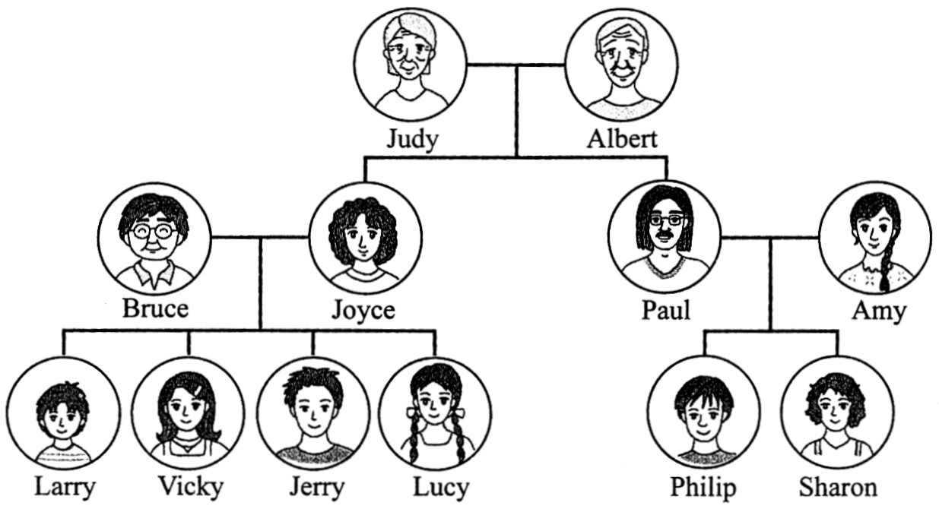

1. Who is Sharon’s cousin? __________ .
(A) Albert (B) Joyce (C) Vicky (D) Philip
2. Who are brother and sister? __________ .
(A) Paul and Joyce (B) Bruce and Amy (C) Jerry and Sharon (D) Larry and Judy
VII、依提示作答：10％
1. This is an old clock. （改成否定句）
2. The tall girl is my sister. （依劃線部份造原問句）
3. How old are you? （依事實回答，數字用英文寫出）
4. Is Mary Wang your teacher? （肯定簡答再詳答）
5. Jay is a good singer.
Jolin is a good singer. （用…and…too合併成一個句子）
VIII、翻譯：15％
1.這隻黑色的狗真醜。
2.你的表弟11歲嗎？不，他8歲。（數字用英文寫出）
3. Cindy的哥哥David Lee是個快樂的醫生。
4.天色暗了。他們又餓又累。
5.布朗先生，你的房子是粉紅色的嗎？是的，而且是新的。
一英語2
一年 班 座號： 姓名：
高雄市立陽明國中99學年度第1學期第1次段考一年級英語科答案卷
訂正後分數 | 訂正教師簽名 | 閱卷分數
I、聽力測驗：16％
A.根據錄音內容，與圖片相符合的寫T，不符合寫F 。6％
1. |  | 2. |  | 3. |  | 4. |  | 5. |  | 6.
B.根據錄音內容，選出適當的答句。10％
1. |  | 2. |  | 3. |  | 4. |  | 5.
II、印刷體大小寫字母互換：10％
1 |  | 2 |  | 3 |  | 4 |  | 5
III、字彙測驗：20％
1 |  | 2 |  | 3 |  | 4 |  | 5
6 |  | 7 |  | 8 |  | 9 |  | 10
IV、文法選擇：20％
1 |  | 2 |  | 3 |  | 4 |  | 5 |  | 6 |  | 7 |  | 8 |  | 9 |  | 10
V、文意填充：5％
1 |  | 2 |  | 3 |  | 4 |  | 5
VI、看圖回答問題：4％
1 |  | 2
VII、依提示作答：10％
1
2
3
4
5
VIII、翻譯：15％
1
2
3
4
5

陽明國中99學年度第1學期第1次段考一年級英語科聽力腳本
A.根據錄音內容，與圖片相符合的寫T，不符合寫F。 ( PAUSE: 3 seconds )
1. Jim and Kim are brother and sister. ( PAUSE: 3 seconds )
2. Mr. Hanks is a doctor, and Mrs. Hanks is a nurse. ( PAUSE: 3 seconds )
3. Hello. We are Class 701. We are in English class. ( PAUSE: 3 seconds )
4. Prince : Hello, Snow White. What’s your phone number?
Snow White : It’s 389-2949. ( PAUSE: 3 seconds )
5. My sister is happy. She is at home. ( PAUSE: 3 seconds )
6. Look at the house. It’s big and beautiful. ( PAUSE: 3 seconds )
B.根據錄音內容，選出適當的答句。 ( PAUSE: 3 seconds )
1. Who is Patty Lin? ( PAUSE: 5 seconds )
2. Nice to meet you, Mr. Brown. ( PAUSE: 5 seconds )
3. This is my new bike. ( PAUSE: 5 seconds )
4. How’s your grandma? ( PAUSE: 5 seconds )
5. Is your mom a good cook? ( PAUSE: 5 seconds )

