一年 班 座號： 姓名：
高雄市立陽明國中99學年度第1學期第2次段考一年級英語科試題
※背面有試題※
一英語1
一、聽力測驗：15％
A：根據你所聽到CD的內容，找到與其相符合的圖片，並填入英文代號：5％
(A) (B) (C) (D) (E) (F)
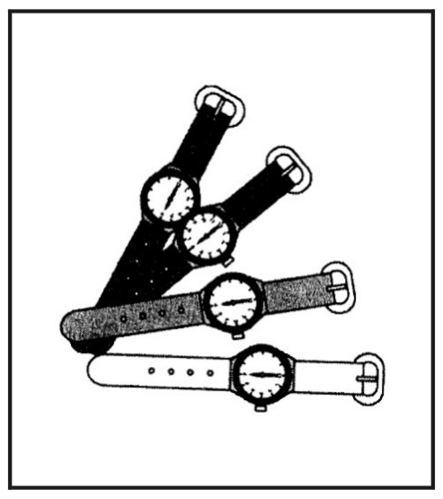
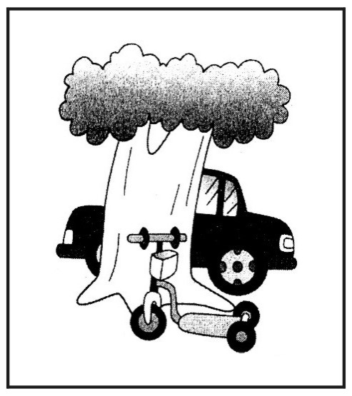
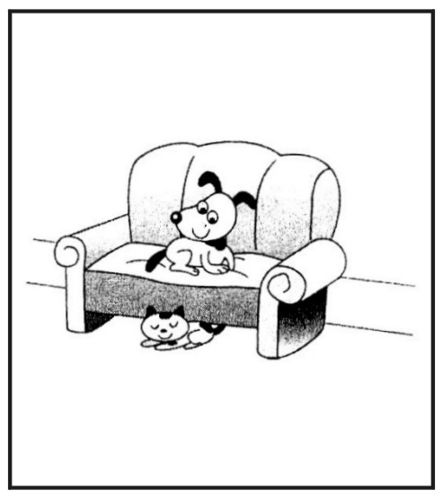
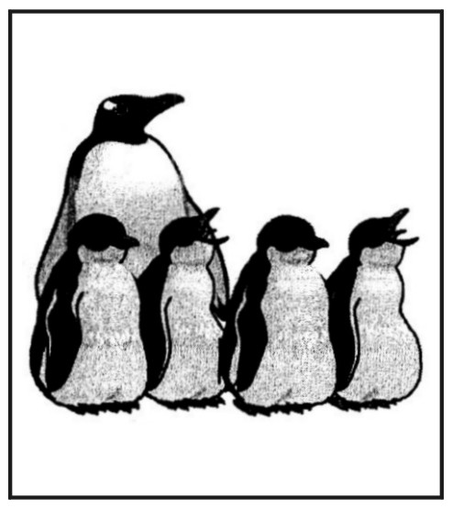
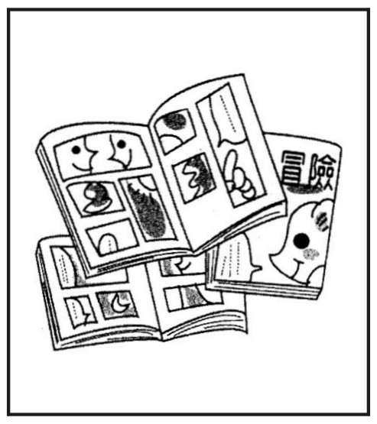
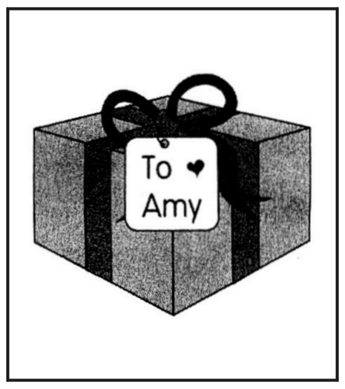

B：根據你所聽到CD的內容，選出適當的答句：10％
1. (A) It’s not a picture. (B) Those are erasers. (C) A book bag.
2. (A) No, it isn’t. (B) Yes, that’s an eraser. (C) No. It’s a ruler.
3. (A) The table is in front of the bathroom.
(B) Dad is in the bathroom.
(C) The bathroom is next to the kitchen.
4. (A) Not bad. (B) That’s interesting. (C) Fine.
5. (A) There are many students in the penguin house.
(B) Great ! Let’s go there.
(C) That’s right. The trees are their toys.
二、字彙測驗（1-5看中文寫英文單字；6-15文意字彙）：30％
1.彩色筆 2.大象 3.袋鼠
4.聰明的 5.猜測
6. There’s nothing to w y about.
You should（應該）look on the bright（光明的）side of things.
7. Students in Ms. Lee’s class have to do exercises in the English w k every week.
8. It’s a good habit（習慣）to b h your teeth（牙齒）after meals（餐）.
9. A：How’s your f y？ B：They’re fine. Thank you.
10. On cold days, hot pots（鍋）are my f e food（食物）.
11. Alice is a new student in my class. She sits b n Emma and Alex now.
12. Debbie is a q t girl. She is not talkative（愛說話的）.
13. Endangered（瀕臨絕種的）Formosan Black Bears are big and strong a from
Taiwan.
14. Today is my b y. I get many cards from my good friends.
15. Mom is busy（忙碌的）cooking dinner（晚餐）in the k n now.
三、文法選擇：20％
1. eat too much candy（糖）, boys. It is bad for your teeth.
(A) No (B) Not (C) Don’t (D) Be
2. On the table my new notebooks.
(A) there is (B) is (C) there are (D) are
3. Julie：Are there tigers at the zoo？
Grace：Yes, but（但是）not .
(A) any；many (B) some；any (C) any；any (D) many；any
4. Allen：How many students in your school？
Betty：I’m not sure.
(A) there are (B) are they (C) are there (D) is there
5. A：Let’s eat in the library（圖書館）. B：OK.
(A) don’t (B) be not (C) not (D) no
6. A： a new Italian（義式的）restaurant（餐廳）downtown（市中心）.
B：That’s great！Let’s go and have lunch there.
(A) It is (B) There are (C) There is (D) That is
7. A：Jill, are they？ B：They are zebras.
(A) where (B) what (C) how (D) how many
8.選出正確的句子。
(A) Where’s your desk？My desk is next my bed. (B) The card for my parents are under the hat.
(C) Aren’t you full？No, I’m not. (D) Debbie, is a good girl at home.
9.選出正確的句子。
(A) There is some tigers and lions in the zoo.
(B) Here is seven monkeys？
(C) There is no any homework today.
(D) A：How many boxes are there under the table？ B：There is one.
10.選出正確的句子。
(A) A：Where are my notebooks？ B：They are under the table.
(B) A：Isn’t there a hippo near the river（河）？ B：Yes, there’s.
(C) A：How many students are there in your class？ B：They are forty.
(D) It’s an elephant, isn’t not a zebra.
四、依提示做答：10％
1. There is one bathroom in my house.（造原問句）
2. Linda is nice to her classmates.（將please放在句尾改成祈使句）
3. There are some lions in the zoo.（改成否定句）
4. That is a fox, not a hippo.（改成複數句）
5. Joyce and Richard are in the bookstore.（造原問句）
五、根據圖片，填入適當的介系詞：5％
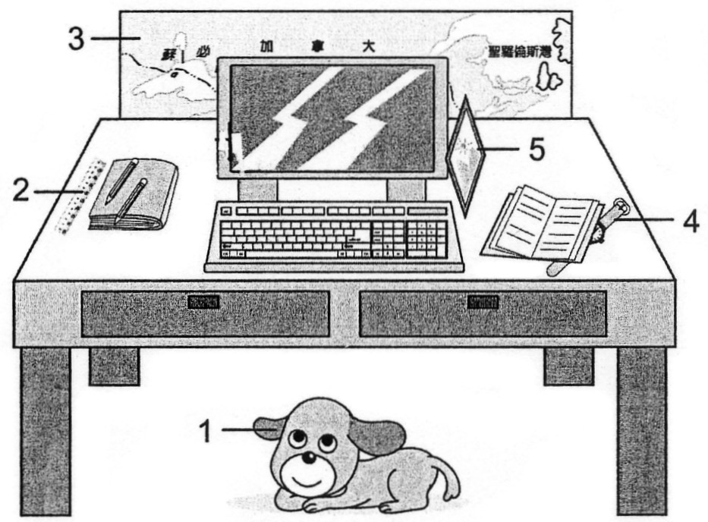

1. The dog is the desk.
2. The ruler is the desk.
3. The map（地圖）is the desk.
4. My watch is the notebook.
5. A picture is to the computer.
※請接第二張※
一英語2
六、閱讀測驗：5％
(A)
Classroom Rules
1. Don’t run.
2. Don’t eat or drink.
3. Be quiet in class.
4. Listen to the teacher in class.
5. Come to class on time.  rule規則；or或；on time準時
1. You can see these rules .  can可以；see看見
(A) in the park (B) at home (C) in a school (D) in a new house
2. Don’t in the classroom.
(A) write (B) read (C) listen (D) run
3. Which is true？  which 哪一個；true真實的
(A) Don’t come to school. (B) Don’t eat in the classroom.
(C) Don’t be quiet in class. (D) Don’t be nice to the teacher.
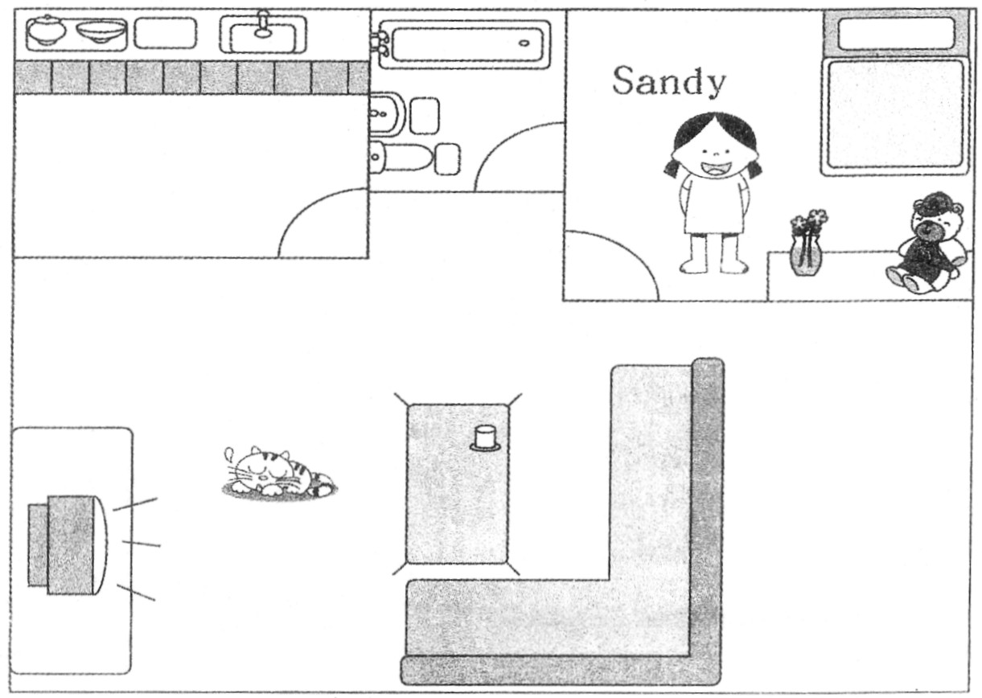
(B)

4. Where is the bathroom？
(A) It’s in Sandy’s bedroom. (B) It’s in front of the dining room.
(C) It’s between the living room and the kitchen. (D) It’s between the kitchen and Sandy’s bedroom.
5. Which is NOT true？  which哪一個；true真實的
(A) There are some tables in the kitchen. (B) There is a cat in the living room.
(C) There isn’t a dining room in the house. (D) There is a toy bear in Sandy’s bedroom.
七、翻譯：15％
1.那些圖畫書是Tom送的，而這個禮物是給你的。
2. A：這附近有一座漂亮的公園嗎？ B：沒錯。
3. A：Molly的背上有什麼呢？ B：一隻小無尾熊。
4. A：你的天竺鼠在哪裡？ B：它在飯廳的餐桌底下。
5. A：Lucy的派對上有幾個家庭？ B：有三個。（數字用英文寫出）
※背面有試題※
一社會1
※第二張※
一英語3
陽明國中99學年度第1學期第2次段考一年級英語科聽力腳本
一、聽力測驗：15％
A：根據你所聽到CD的內容，找到與其相符合的圖片，並填入英文代號：5％
（每題只唸一遍）
1. A：Is the gift for Lucy？
B：No, it’s for Amy. （Pause 5 seconds.）
2. A：What are those？
B：They’re watches. （Pause 5 seconds.）
3. A：Are those notebooks？
B：No, they’re comic books. （Pause 5 seconds.）
4. Look！A scooter is in front of the tree. （Pause 5 seconds.）
5. A：How many penguins are there？
B：There are five. （Pause 5 seconds.）
B：據你所聽到CD的內容，選出適當的答句（每題只唸一遍）
1. What is it？（Pause 8 seconds.）
2. Isn’t that a ruler？（Pause 8 seconds.）
3. Who is in the bathroom？（Pause 8 seconds.）
4. Look！There’s a little monkey on the horse’s back. （Pause 8 seconds.）
5. There are new koalas in Taipei Zoo. （Pause 8 seconds.）
一年 班 座號： 姓名：
高雄市立陽明國中99學年度第1學期第2次段考一年級英語科答案卷
訂正後分數 | 訂正教師簽名 | 閱卷分數
一、聽力測驗：15％
A：根據你所聽到CD的內容，找到與其相符合的圖片，並填入英文代號：5％
1. |  | 2. |  | 3. |  | 4. |  | 5.
B：根據你所聽到CD的內容，選出適當的答句：10％
1. |  | 2. |  | 3. |  | 4. |  | 5.
二、字彙測驗（1-5看中文寫英文單字；6-15文意字彙）：30％
1 |  | 2 |  | 3 |  | 4 |  | 5
6 |  | 7 |  | 8 |  | 9 |  | 10
11 |  | 12 |  | 13 |  | 14 |  | 15
三、文法選擇：20％
1 |  | 2 |  | 3 |  | 4 |  | 5 |  | 6 |  | 7 |  | 8 |  | 9 |  | 10
四、依提示做答：10％
1
2
3
4
5
五、根據圖片，填入適當的介系詞：5％
1 |  | 2 |  | 3 |  | 4 |  | 5
六、閱讀測驗：5％
1. |  | 2. |  | 3. |  | 4. |  | 5.
七、翻譯：15％
1
2
3
4
5

