二年 班 座號： 姓名：
高雄市立陽明國中99學年度第1學期第2次段考二年英語科試題
※背面有試題※
二英語1
一、聽力測驗：20％
I.看圖選出正確的答案 5％
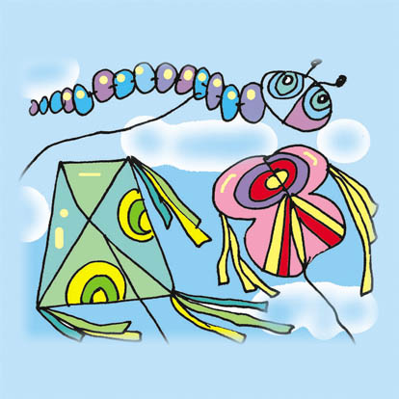
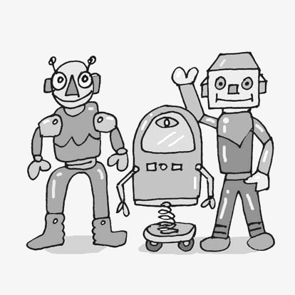
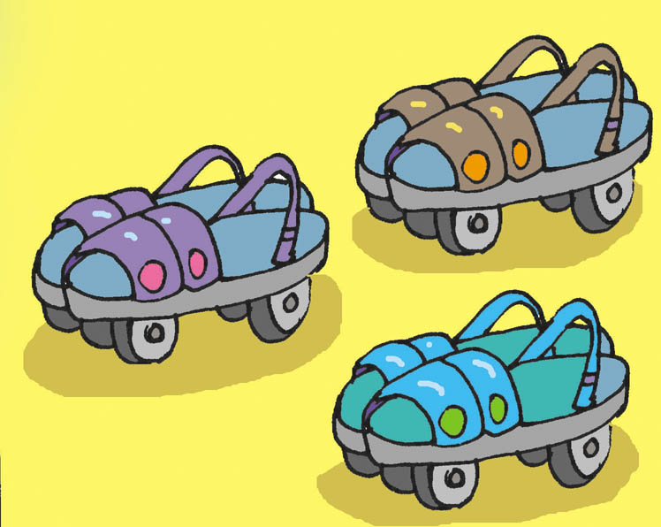
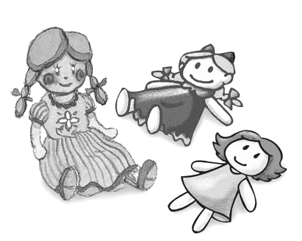
1.① ② ③ ④

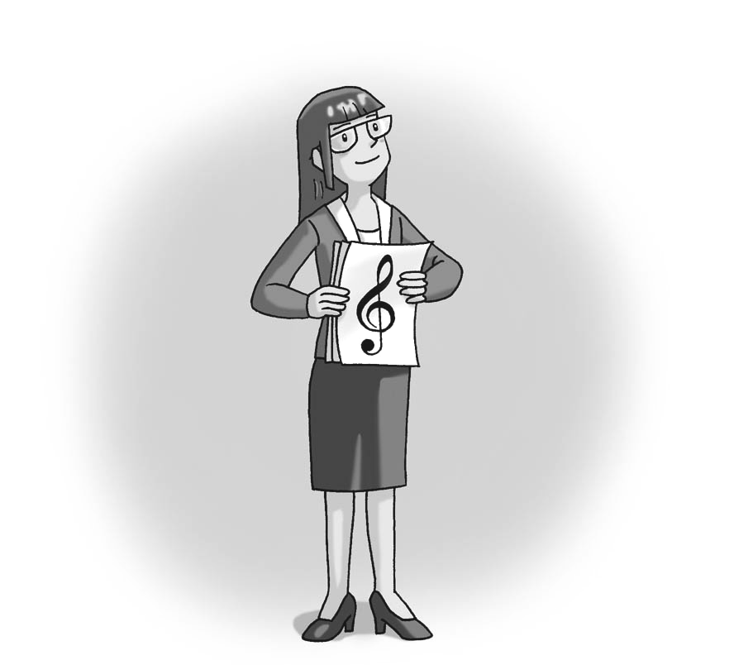
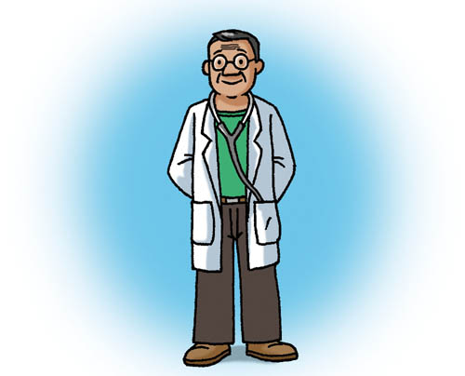
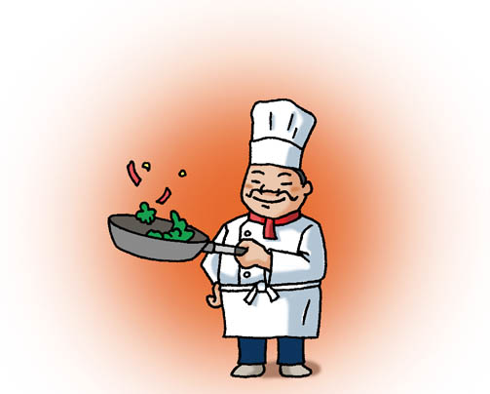
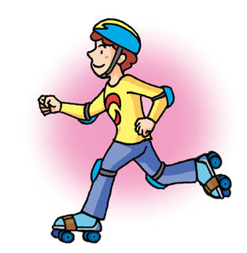
2. ① ② ③ ④

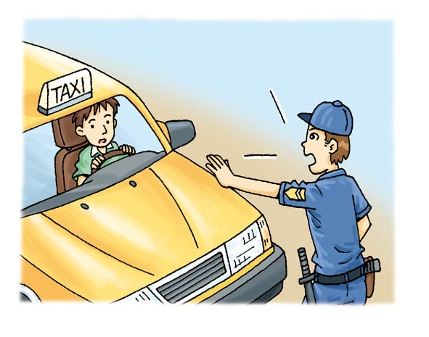
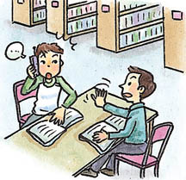
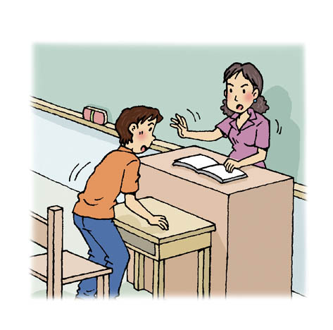
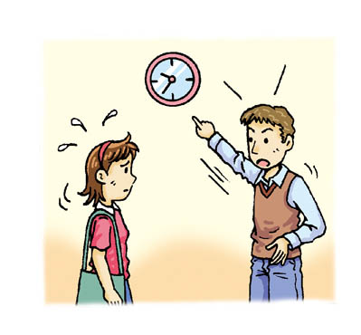
3. ① ② ③ ④

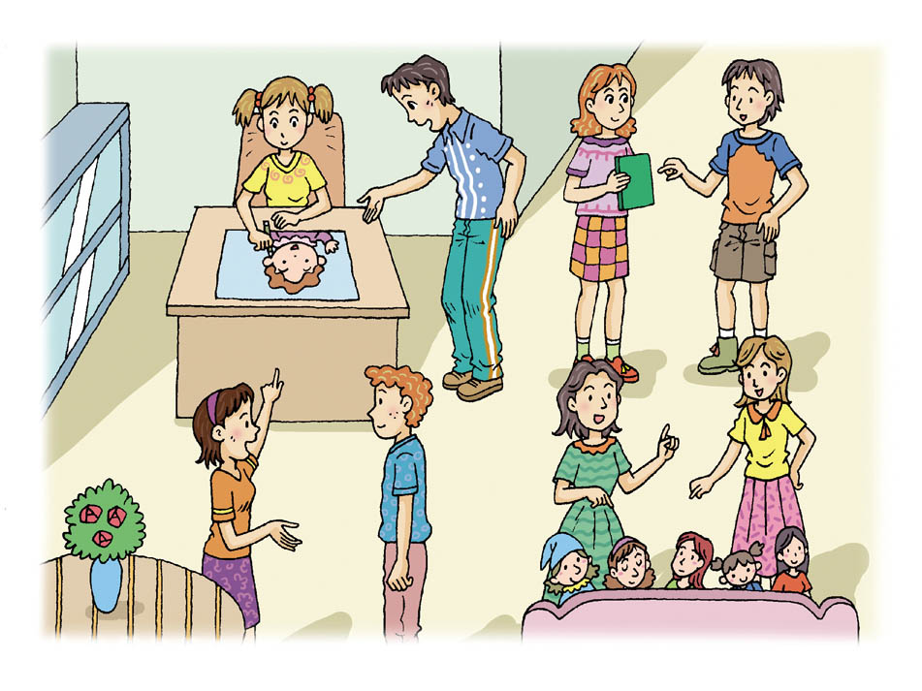
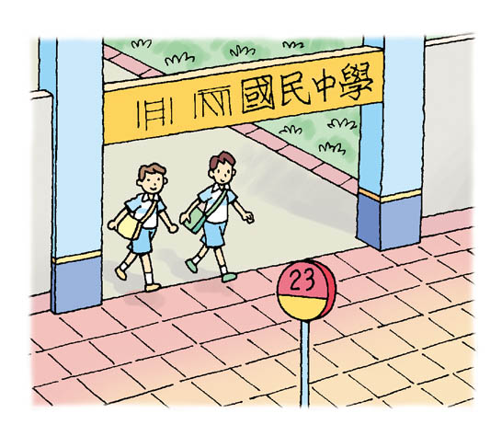
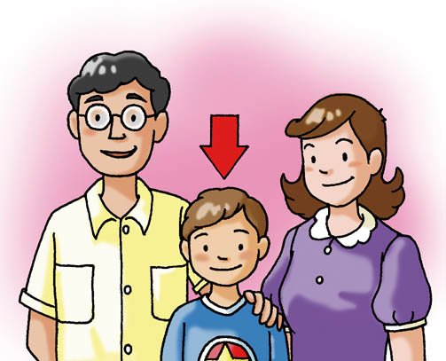
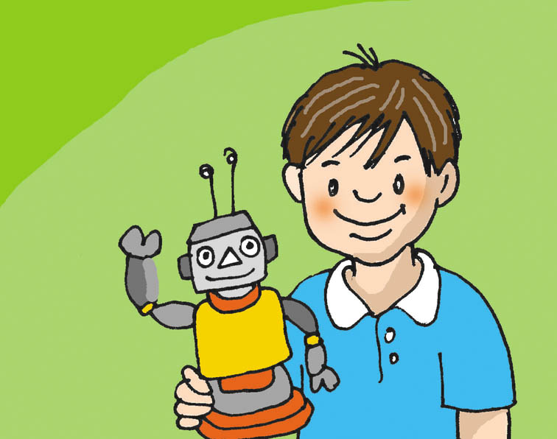
4. ① ② ③ ④

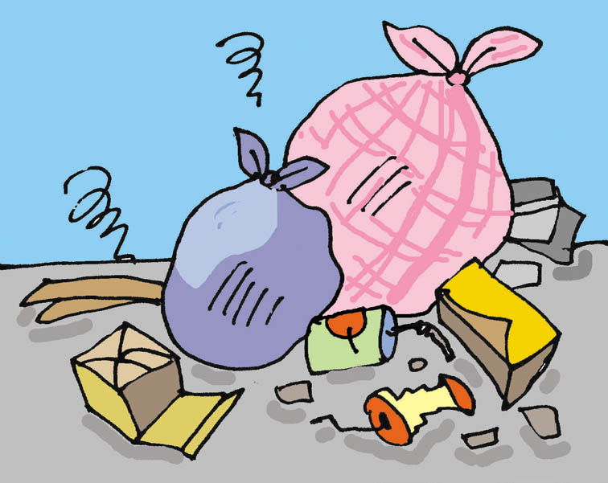
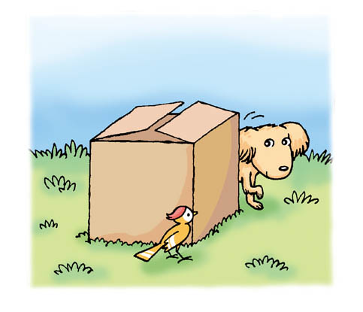
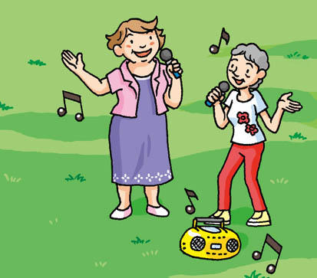
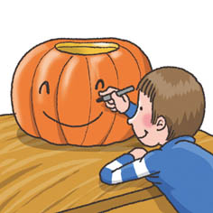
5. ① ② ③ ④

II.依照對話內容，從①②③選出最適合的答案回答相關問題：5％
1. ① In the dining room. ② In a restaurant. ③ In the kitchen.
2. ① She watches English movies a lot. ② She listens to English songs a lot. ③ She reads English books a lot.
3. ① She was studying then. ② She didn’t want to answer it. ③ She left her cellphone in a restaurant.
4. ① He took care of his sick cat all night. ② He only slept after midnight. ③ He didn’t feel well because he got sick.
5. ① They got red because of red paint. ② They got sick because of the chair. ③ They got red because of the woman.
III.聽完文章內容依問句從①②③選出最適合的答案：10％
1. ① In a museum. ② In her bedroom. ③ In the forest.
2. ① It tried to hurt Janice. ② It tried to save Janice. ③ It tried to kiss Janice.
3. ① Her i-phone. ② Her i-pad. ③ Her e-book.
4. ① Open the door. ② Close the window. ③ Close the door.
5. ① Two police officers. ② Two poor old men. ③ Two expensive pens.
二、文字測驗：80％
I.字彙測驗：20％
1. A: I was Ironman in my dream last night.
B: No wonder you f______t bad guys and saved me in my dream last night.
2. Don’t a_______k anyone when you are very angry. You may hurt someone seriously.
3. Table m_______s are important when you are having dinner with foreigners in the foreign country.
4. Many teenagers enjoy c_________g the pictures of their idols such as Super Junior or Wonder girls from Korea.
5. Ms. Clark p________s students a lot when they do right. She makes them feel very cheerful.
6. It’s not p_______e to talk with people very loudly in public, especially in the library or in the hospital.
7. Americans can’t eat large steak with c________s but a knife and fork.
8. Be very c_________l about your English exam this time! It is not so easy, and you may make lots of mistakes easily.
9. Students in the class were noisy after the bell rang. The class leader cried out, “Here comes the teacher. Shhhhh……..” S______y everyone shut his mouth up and became very quiet.
10.Children say “trick or t________t?” on Halloween to get lots of candy.
II.文法選擇：20％
1. Let’s stop ______ TV now. We have to do a lot of homework today.
① watch ② to watch ③ to watching ④ watching
2. _________ a car without ________ your hands is very dangerous.
① Driving ; to use ② To drive ; to use ③ Driving ; using ④ Drive ; using
3. Dinner was ready, but Helen _______ it. She _______ with her boyfriend on the phone.
① didn’t eat ; is ② wasn’t having ; was talking ③ was eating ; talked ④ wasn’t having; was
4. ________ is good for us.
① Correct bad habits ② Have a close friend ③ Good friends ④ Doing healthy exercise
5. “S.H.E.were talking about not going to the store again.” It means “___________”
① S.H.E. weren’t talking about going to the store. ② S.H.E. didn’t want to go to the store again.
③ S.H.E. didn’t want to talk to the store again. ④ S.H.E. were talking when they went to the store.
6. _________ English well, we have to use it every day.
① To learn ② Learn ③ Learning ④ Learned
7. Don’t keep me __________ too long. It’s dark here.
① wait you ② to wait for you ③ for waiting you ④ waiting for you
8. A: Hey, why not _______ to see the movie with us? B: I want to, but my father told me ________ too much.
① going out ; not to play ② go out ; not to play ③ to go out ; don’t play ④ don’t go out ; not play
9. Which sentence is correct?
① To going fishing is fun. Some people do it all the time on the weekend.
② It was wonderful to walking with you then.
③ I saw you and your parents at the party at 8:30 last night.
④ Having good habits are not easy for someone.
10. Which sentence is correct?
① It’s getting cold. You have to bring a jacket with you.
② Jack did play computer games at all. He was free.
③ There are something strange on his mind, but he doesn’t want to tell anyone.
④ Some teenagers get into trouble easily because they don’t want anyone help them on their problems.
 get into trouble惹禍上身
※請接第二張※
二英語2
III. 填充：4％
Dear Spoon Killer,
What did you do 1. my useful spoon? Did you throw it 2. my cute pet, Mimi, because of her loud voice? You know in my heart, she is very important to me. You can’t stop her 3. throwing things. I took away your spoon because I couldn’t find my spoon. Please have lunch 4. your dirty fingers. Have a nice day!
Spoon Robber
 robber強盜
IV. 填入正確的動詞型態：5％
1. Bill has serious problems in _________ (get) together with his classmates.
2. Eating breakfast and exercising every day ________ (be) good for you.
3. I am afraid ________ (be) late for school again.
4. ________ (prepare) for your math test well, and you may get good grades.
5. _________ (learn) Japanese on the weekend is interesting for me.
V.閱讀測驗：6％
Lucy is a considerate child. When her mother wants to buy some daily groceries for the family, Lucy always goes to the supermarket with her mother. She wants to give her mother a hand to carry the heavy things. She is very helpful. Besides, Lucy likes to shop in the supermarket but not in the department store. It is more fun for her to shop in the supermarket. Things in the supermarket look delicious and attractive. And she can also learn a lot of English words in the supermarket. Lucy’s teacher once gave the class a special assignment. She asked her class to go to a supermarket and write down ten English words. When Lucy went into a supermarket, she found many interesting words on the labels of different kinds of food. And she learned a lot at that time. For her, it is a good place to learn English and she can help her mother at the same time.
 considerate善解人意的；daily groceries日常用品；besides除此之外；attractive吸引人的；assignment指定作業；label標籤
1.What does give her mother a hand mean?
① To help her mother. ② To give her mother one of her hands.
③ To show her mother her English words. ④ To hold her mother’s hands.
2. Why does Lucy like to shop in the supermarket?
① She can watch TV. ② She can teach her mom.
③ She can learn English words. ④ She can see labels.
3.What is the title for the reading?  title題目／標題
① Lucy and Her Weak Mother.  weak虛弱的
② Having Fun Learning English in a Supermarket.
③ How to Help People and Learn English at the Same Time.
④ Children Should Help Their Parents in the Supermaket.
VI.依提示作答：10％
1. Mary ate pizza and drank cola yesterday afternoon. (加入十二點三十分)
2. Doing reports about music with John in the library is important for him. (用It當主詞改寫)
3. I didn’t use a knife and fork to eat steak. (用without改寫句子)
4. She grew some flowers with John after lunch. (在句首加入Mom needed)
5. John bought a house for his wife last year. (在John後加入plan改寫)
VII. 翻譯：15％
1.我的夢想是成為一位勇敢的警官。
2.當我在今天早上六點三十分醒來時，媽媽在為我做三明治。
3.她要Jenny不要製造太多的噪音因為她正在練習寫電子郵件。
4.對日本人來說，喝湯時以碗就口是很正常的。 (It……….)
5.我正考慮在空閒時幫爺爺研究葉子。
※第二張※
二英語3
二年 班 座號： 姓名：
高雄市立陽明國中99學年度第1學期第2次段考二年級英語科答案卷
訂正後分數 | 訂正教師簽名 | 閱卷分數
一、聽力測驗：20％
I.看圖選出正確的答案 5％
1. |  | 2. |  | 3. |  | 4. |  | 5.
II.依照對話內容，從①②③選出最適合的答案回答相關問題：5％
1. |  | 2. |  | 3. |  | 4. |  | 5.
III.聽完文章內容依問句從①②③選出最適合的答案：10％
1. |  | 2. |  | 3. |  | 4. |  | 5.
二、文字測驗：80％
I.字彙測驗：20％
1 |  | 2 |  | 3 |  | 4 |  | 5
6 |  | 7 |  | 8 |  | 9 |  | 10
II.文法選擇：20％
1 |  | 2 |  | 3 |  | 4 |  | 5 |  | 6 |  | 7 |  | 8 |  | 9 |  | 10
III.填充：4％
1 |  | 2 |  | 3 |  | 4
IV.填入正確的動詞型態：5％
1 |  | 2 |  | 3 |  | 4 |  | 5
V.閱讀測驗：6％
1 |  | 2 |  | 3
VI.依提示作答：10％
1
2
3
4
5
VII. 翻譯：15％
1
2
3
4
5

