二年 班 座號： 姓名：
高雄市立陽明國中99學年度第1學期第3次段考二年英語科試題
※背面有試題※
二英語1
一、聽力測驗：20％
I、聽CD，配合圖片選出最適當的答案。5％
(A) (B) (C) (D) (E) (F)
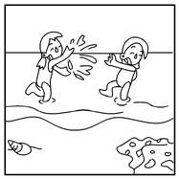
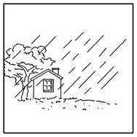
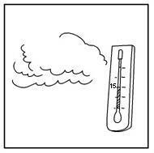
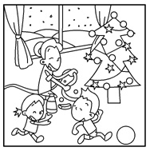
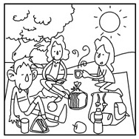
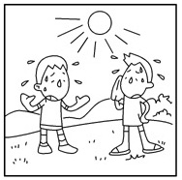
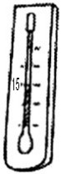
15

1. 2. 3. 4. 5.
II、聽CD對話，填入做下列活動的人的名字。5％ Andy Bob Tom
(A) (B) (C) (D) (E)
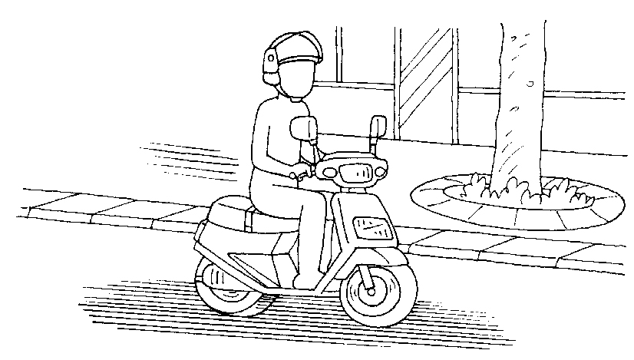
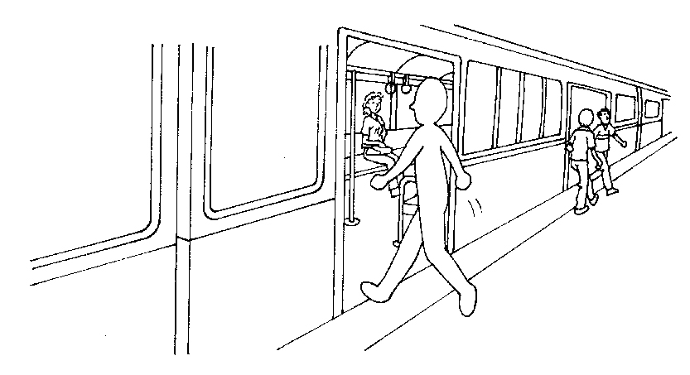
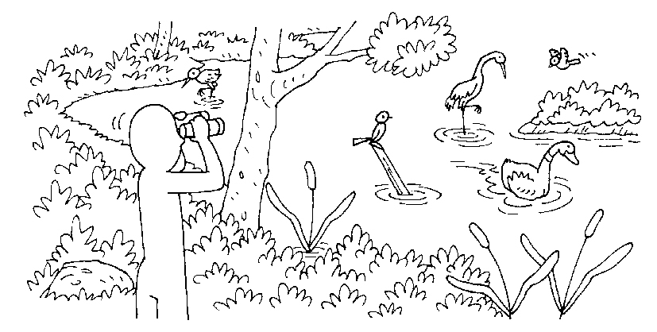
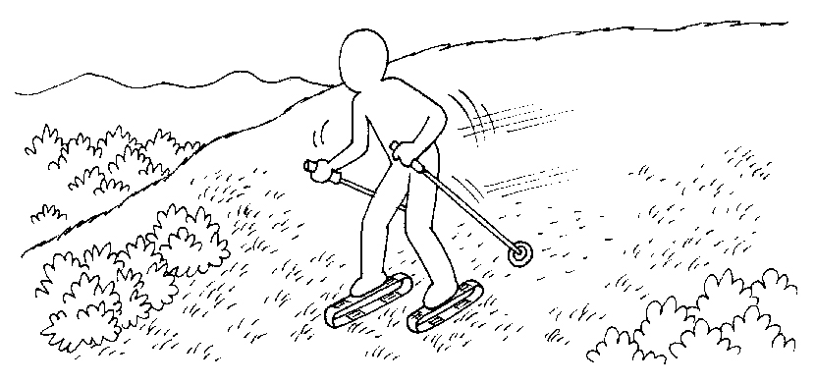
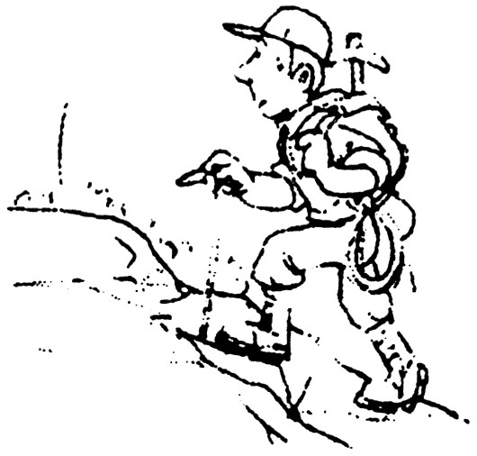

III.聽完對話內容依問句選出最適合的答案：10％
1. (A) By HSR（高鐵）. (B) By train. (C) By car.
2. (A) Go shopping. (B) Make wishes at the temple. (C) Eat dinner at the restaurant.
3. (A) It was snowy. (B) It was rainy. (C) It was sunny.
4. (A) She couldn’t find an umbrella.
(B) Justin didn’t invite her to the party.
(C) She didn’t finish her homework.
5. (A) It’s July. (B) It’s August. (C) It’s September.
二、文意字彙：20％
1. Don’t open the e________e. I want to be the first person to read the letter.
2. Bill stops eating fast food to lose（減少）w________t.
3. On New Year Day, people like to watch beautiful f________ks in the night sky.
4. John has a r_______y nose. He gets sick now.
5. In Canada, winter comes in N________r.
6. People often say, “A________l showers bring May flowers.”
7. Tony likes to play computer games all day. He is really a mouse（滑鼠）p________o.
8. The aboriginal boy is from Mount Ali（阿里山）. It is his h________n.
9. A：How will you c________e Dad’s birthday？ B：We’ll have a party for him.
10. The Chinese New Year this year is in F________y.
三、文法選擇：20％
1. A：Do you ever see a ghost？ B：No, __________.
(A) I never (B) I am never (C) I never do (D) I do never
2. ______ she flies a kite on Sunday.
(A) Sometimes (B) Never (C) Often (D) Seldom
3. ______ heavily in Taipei now.
(A) It is rain (B) We have rain (C) There’s raining (D) It’s raining
4. There ______ many people shopping in Dream Mall during the Chinese New Year.
(A) should have (B) should be (C) is going to be (D) is going to have
5. Why not ______ with me this afternoon？
(A) go jogging (B) go jog (C) going jog (D) going jogging
6. Leo usually eats bread for breakfast. He ______ eats rice.
(A) seldom (B) usually (C) often (D) always
7. Peter ______ to the school in ten minutes.
(A) come (B) comes (C) came (D) is coming
8. In Taiwan, many people like to play mahjong（麻將）______ Chinese New Year’s Eve.
(A) on (B) in (C) at (D) during
9. I will visit Taipei International Flora Exposition（花博）______ January 22.
(A) in (B) on (C) at (D) during
10.選出正確句子
(A) To your health, you need to exercise.
(B) My brother will ride motorcycle to Pingtung.
(C) All is white on New Year holidays in Canada.
(D) Her parents will take us to Lugang by their car.
四、動詞形式：5％
1. Who ___________ （wash）the dishes？ Mark will.
2. Who ___________ （wash）the dishes？ John did.
3. Who ___________ （wash）the dishes？ Mark and John are.
4. Who ___________ （wash）the dishes？ Mark does.
5. Mary ___________ （be）at home tomorrow, but I will.
五、克漏字選擇：7％
The weather in Taiwan is different from season to season. It is warm in spring, hot in summer, cool in autumn and cold in winter. But we had a 1. winter last year. In December, it was sometimes very hot 2. summer and sometimes so cold. People 3. T-shirts for one week and coats or sweaters for another. The weather changed very fast, so people got 4. very often. The same story
5. in January this year. The story didn’t 6. . 7. we have a different spring this year？ Let’s wait and see.
Change改變
1. (A) terrible (B) bright (C) important (D) polite
2. (A) during (B) in (C) like (D) for
3. (A) washed (B) waited (C) wrote (D) wore
4. (A) busy (B) sick (C) poor (D) sleepless
5. (A) fought (B) kept (C) happened (D) told
6. (A) end (B) start (C) go (D) finish
7. (A) Are (B) Will (C) Do (D) Did
六、閱讀測驗：3％
Ingvar Kamprad was just 17 years old when he started IKEA. In 1943, he sold pens, wallets, watches, jewelry and other small things. But by 1955, Kamprad was designing his own furniture. At first, people could only buy things from his home or from catalogs. Then he opened his first shop in 1963. Now IKEA is very popular around the world.
 wallet皮夾；jewelry珠寶；design設計；furniture傢俱；catalog目錄
※請接第二張※
二英語2
1. What is this passage mainly about？
(A) Kamprad and his family. (B) Kamprad’s favorite hobbies.
(C) Kamprad and his business. (D) Kamprad’s early education.
2. What did Kamprad probably sell at first？
(A) Land. (B) Music. (C) Cars. (D) Rings.
3. According to this passage, what was true about Kamprad’s things in 1955？
(A) They were quite expensive. (B) They were not in stores.
(C) They were for sale everywhere. (D) They were not made very well.
七、依題示作答：10％
1. There is a good movie on TV.（用will改寫）
2. Ken cooks dinner for him every day.（根據劃線部份造原問句）
3. Is there usually a lot of rain here？
(A)用…it…改寫
(B)用…we…改寫
4. Ted will go to Taipei tomorrow.
（用by合併）
He will drive his car tomorrow.
八、翻譯：15％
1.我們青少年一星期至少應該運動三次。
2.我們將在廟裡點光明燈和許願。
3.讓我們和我們最愛的歌手們一起新年倒數。
4.許多小孩在聖誕假期期間滑雪橇。
5.他的奶奶從不吃薯條，但是他常常吃。
※第二張※
二英語3
陽明國中99學年度第1學期第3次段考二年級英語科聽力腳本
一、聽力測驗：20％
I、聽CD，配合圖片選出最適當的答案。5％
(1) Many children like to play at the beach in summer.
(2) It’s the time to have a picnic in the park.
(3) It’s rainy during the Christmas vacation.
(4) It was not very hot this morning.
(5) The family had a white Christmas.
II、聽CD對話，填入做下列活動的人的名字。5％
1. Andy, Bob, and Tom are brothers. They like to go outside on weekends. Next Saturday, Andy will go bird watching in Danshui. He will go there by MRT. Bob likes to go hiking in the mountains. So he’s going to ride his scooter to the mountains. His friends will meet him there. Tom will go grass skiing. His classmates will drive a car. And they will go together.【習作】
III.聽完對話內容依問句選出最適合的答案：10％
1. Man: What are you going to Kaohsiung for?
Woman: I am going to visit my parents.
Man: Will you take the HSR or the train to Kaohsiung?
Woman: No, my husband will drive me there.
Question: How will the woman go to Kaohsiung?
2. Man: I plan to buy some clothes this evening. Do you want to go with me?
Woman: Sure. Where should we meet?
Man: Let’s meet in front of the temple.
Woman: OK. It’s a deal.
Question: What will the man and the woman do this evening?
(3.～5.)
Man: Why didn’t you go to Justin’s birthday party last Saturday? Didn’t he invite you to his party?
Woman: Yes, he did. I knew his birthday party was on August 31st. But I couldn’t go out.
Man: Why? Didn’t you finish your homework?
Woman: Yes, I did.
Man: Then, why couldn’t you go out?
Woman: When I went out of my home, it started to rain suddenly. And I couldn’t find any umbrella in my home.
Man: Poor you.
3. What was the weather like last Saturday?
4. Why didn’t the woman go to Justin’s party?
5. What month is it?
二年 班 座號： 姓名：
高雄市立陽明國中99學年度第1學期第3次段考二年級英語科答案卷
訂正後分數 | 訂正教師簽名 | 閱卷分數
一、聽力測驗：20％
I、聽CD，配合圖片選出最適當的答案。5％
1. |  | 2. |  | 3. |  | 4. |  | 5.
II、聽CD對話，填入做下列活動的人的名字。5％
A |  | B |  | C |  | D |  | E
III.聽完對話內容依問句選出最適合的答案：10％
1. |  | 2. |  | 3. |  | 4. |  | 5.
二、文意字彙：20％
1 |  | 2 |  | 3 |  | 4 |  | 5
6 |  | 7 |  | 8 |  | 9 |  | 10
三、文法選擇：20％
1 |  | 2 |  | 3 |  | 4 |  | 5 |  | 6 |  | 7 |  | 8 |  | 9 |  | 10
四、動詞形式：5％
1 |  | 2 |  | 3 |  | 4 |  | 5
五、克漏字選擇：7％
1 |  | 2 |  | 3 |  | 4 |  | 5 |  | 6 |  | 7
六、閱讀測驗：3％
1 |  | 2 |  | 3
七、依題示作答：10％（每句2分）錯一字扣1分
1
2
3 | (A)
 | (B)
4
八、翻譯：15％
1
2
3
4
5

