一年 班 座號： 姓名：
※背面有試題※
一英語1
高雄市立陽明國中99學年度第2學期第1次段考一年級英語科試題
一、聽力測驗：20％
Ⅰ、每題有3個敘述，選出與圖片相符合的敘述：5％（注意每題只唸一次）
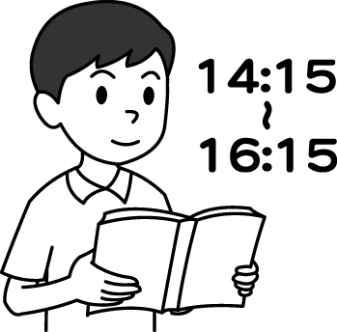
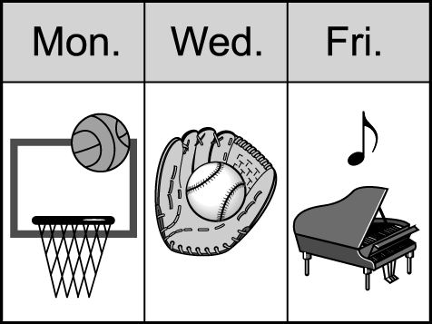
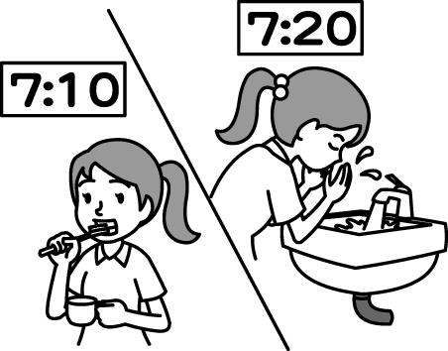



1. 2. 3. 4. 5.
Ⅱ、根據對話內容，符合對話敘述者請寫〝 T 〞，不符合者請寫〝 F 〞：5％
1. Tom’s brother is good at basketball.
2. Leo’s sisters don’t like comic books.
3. The boy’s mother uses a computer at home.
4. Peter’s teacher is talking to Peter’s father.
5. Leo is playing with some rats now.
III、聽問句，選出適當的答句：10％
1. (A) No, I can't sleep. (B) Of course, I am running. (C) The weather is fine. (D) Not too good. I'm tired.
2. (A) He has small blue eyes. (B) He swims. (C) He is in his bedroom. (D) He can’t play it .
3. (A) Yes, she does. (B) No, I don’t. (C) Yes, I study every day. (D) No, I don’t play baseball.
4. (A) Yes, Mary can help. (B) No, I don’t like it. (C) Tony can help you. (D) Mike can not help you.
5. (A) It’s time for lunch. (B) Yes. Do you? (C) OK. What about 2:00 p.m.? (D) Sure. What’s up?
二、文字測驗：80％
Ⅰ、書寫體辨識：5％
1. hide ______________ 2. earthquake ______________
3. .biology ______________ 4. tsunami ______________
5. Jack ______________
Ⅱ、字彙部分：10％
1. Ted: Where are the students? Sara: It’s raining. They are playing basketball in the g .
2. Don’t work on your c r for a long time. It’s not good for your eyes and body.
3. Kelly is calling Miss Chen for h p.
4. Let’s enjoy the w l party with our friends.
5. Rendy Lu and Andy Roddick are well-known t s players. Everyone knows them.
6. Meg is c g a baby on her back and talking on the phone.
7. May is my cousin, Uncle Sam’s d r.
8. Students have to eat b t before they go to school.
9. Thirty and seventy make one h d .
10. My little sister can c t numbers well.
Ⅲ、語法測驗：20％
1. Jack _______ a lot of fish every day.
(A) cans catch (B) can catches (C) is catching (D) can catch
2. the boys watch the TV program One Million Star now?
(A) Cannot (B) Cann’t (C) Can’t (D) Can not
3. Jim is too lazy. He only after dinner without(沒有) studying.
(A) is watch TV (B) watch TV (C) is watching TV (D) watches TV
4. A：What time Amy go to Chinese class? B：At eight ten.
(A) do (B) does (C) is (D) are
5. A： you jump rope? B：No, I don’t.
(A) Do (B) Can (C) Are (D) May
6. I can’t dance sing, I can write interesting stories.
(A) but ; and (B) and ; but (C) or ; but (D) or ; and
7. Music and sports a lot of fun.
(A) do (B) has (C) is (D) can be
8. Paul is very good at sports. He can play dodge ball well, but he can’t play drums.
(A) × ; the (B) the ; the (C) × ; × (D) the ; ×
9. _______ the man. He _______ stories for his children.
(A) Look；is reading (B) See；is studying (C) Watch；is saying (D) Look at；is reading
10. Which sentence is correct?（句子何者正確）
(A) Do they thin? Yes, they do. (B) Everything is fine. Don’t worry.
(C) Does he like fish? Yes, he likes. (D) We watch a lot of TV on every Sunday.
Ⅳ、請填入正確動詞變化。10％
1. Mom cooks dinner and Dad (wash) dishes.
2. Oscar (fly) a kite in the park and Ben does, too.
3. Sarah , ( not talk) to Mom like that.
4. George (love) painting very much now.
5. My sister _______(go) to bed late(晚) ,but I do.
Ⅴ、克漏字選擇：5％
Clerk: Hello, Happy Pizza House!
Mrs. White: Hello, I want a pizza. Can you 1 English?
Clerk: Yes, ma’am.
Mrs. White: I’d like a small seafood pizza and a large coke.
Clerk: OK, a small seafood pizza and a large coke. 2
Mrs. White: That’s all.
Clerk: 3 I have your 3 and the address?
Mrs. White: Lisa White. No. 25, Yi-Hua Rd.
Clerk: Excuse me. Which road? Can you 4 that for me?
Mrs. White:Y--I-H-U-A, Yi-Hua Rd .
Clerk: Got it. And your pizza will be there in 5 30 minutes. Thank you.
 seafood海鮮 address地址 road路 will將
1. (A) listen (B) talk (C) speak (D) say
2. (A) Hold on, please. (B) Anything else? (C) Here you are. (D) How about the food?
3. (A) Can ; money (B) May ; family (C) May ; name (D) Can ; number
4. (A) write (B) say (C) draw (D) spell
5. (A) for (B) about (C) at (D) on
※請接第二張※
一英語2
Ⅵ、閱讀測驗：6％
Ben : Hello, Tony. This is Ben. Are you free this Sunday morning?
Tony : Not really. What’s up?
Ben : Let’s go to Dream Mall. There’s a good movie on Sunday morning.
Tony : But I have to study. We have math and Chinese tests on Monday.
Ben : But you can do that on Saturday or Sunday evening.
Tony : Well…. OK. Who else is going?
Ben : My classmates, Lisa and Nora. Let’s meet at your home at 10 a.m.
Tony : Fine.
 free有空的 Dream Mall夢時代 have to必須
1. Ben and Tony are talking ________.
(A) about school (B) to Lisa and Nora (C) in Dream Mall (D) on the phone
2. What does do that mean?  mean意指
(A) Study for the tests. (B) Have math and Chinese tests. (C) Go to a movie. (D) We don’t know.
3. Which is true?
(A) Lisa and Tony are classmates. (B) Two boys and two girls are going to the movie.
(C) Tony can’t go to the movie. (D) Lisa and Nora are now at Tony’s home.
Ⅶ、依提示作答：10％
1. I am smart, and I study English.（改I為he）
2. Peter has long hair. (改為否定句)
3. Is David doing his homework now？ (改now為every day )
4. No, you can’t go out with me.（造原問句）
5. They clean the house at ten on Sundays. （造原問句）
Ⅷ、翻譯：14％（第2題2分，其餘每題3分）
1.那頭大象會握畫筆並畫出美麗的花朵。
2. Kelly每週末看電影，Helen也是。
3.你放學後做些什麼？我和朋友們上網。
4.我的父母每天照顧我和我的家人。
5.那個英俊的男孩可以從週一到週五聽音樂1小時。
※第二張※
一英語3
※第二張※
一英語3
陽明國中99學年度第2學期第1次段考一年級英語科聽力測驗腳本
(本測驗時間勿超過5分鐘)
一、聽力測驗：20％
I、每題有3個敘述，選出與圖片相符合的敘述：5％（注意每題只唸一次）
（速度 正常。第1次唸完 無須間隔）
1. (A) The girl’s hair is not long.
(B) The girl has thin lips.
(C) The girl’s eyes are small.
2. (A) She brushes her teeth at ten.
(B) She washes her head at seven twenty.
(C) She washes her face at seven twenty.
3. (A) The girl can ride a bike well.
(B) The girl can roller-skate well.
(C) The girl can sing well.
4. (A) Mary plays sports on Monday.
(B) Mary plays the piano on Wednesday.
(C) Mary watches TV on Friday.
5. (A) He studies for an hour.
(B) He studies in the morning.
(C) He studies for one hundred and twenty minutes.
II、根據對話內容，符合敘述者請寫 ” T”，不符合者請寫 ” F” ：5％
（本大題唸2次，速度 正常。第1次唸完間隔 約2秒，第2次問完問題間隔 約3秒）
1. G: Tom, your brother has really long legs!
B: Yes, and he is on the school basketball team.
2. G: Don’t your sisters like comic books, Leo?
B: Yes, they do, but they don’t read comic books every day.
3. G: Does your mother surf the Net at home?
B: No. She doesn’t have a computer.
4. Man：Hello?
Ms.Lin：Hello, this is Ms.Lin,Peter’s teacher. Is Peter’s father there?
Man：Peter？ Sorry , you have the wrong number.
Ms.Lin：But isn’t this 341-7059？
Man：Yes, but there is no Peter here.
5. G: How’s everything, Leo?
B: Not so good. There are rats in my house.
III、聽問句，選出適當的答句：10％
(本大題唸2次，速度 正常，第1次問完問題間隔 約3秒，第2次問完問題間隔 約4秒)
1. Hi Vicky, nice to see you here. How are you doing?
2. What does your cousin do on weekends?
3. Do you like music, Jenny?
4. Who can help me with my homework?
5. Do you have time this afternoon?
一年 班 座號： 姓名：
高雄市立陽明國中99學年度第2學期第1次段考一年級英語科答案卷
訂正後分數 | 訂正教師簽名 | 閱卷分數
一、聽力測驗：20％
Ⅰ、選出與圖片相符合的敘述：5％（注意每題只唸一次）
1. |  | 2. |  | 3. |  | 4. |  | 5.
Ⅱ、根據對話內容，符合敘述者請寫〝 T 〞，不符合者請寫〝 F 〞：5％
1. |  | 2. |  | 3. |  | 4. |  | 5.
III、聽問句，選出適當的答句：10％
1. |  | 2. |  | 3. |  | 4. |  | 5.
二、文字測驗：80％
Ⅰ、書寫體辨識：5％
1 |  | 2 |  | 3 |  | 4 |  | 5
Ⅱ、字彙部分：10％
1 |  | 2 |  | 3 |  | 4 |  | 5
6 |  | 7 |  | 8 |  | 9 |  | 10
Ⅲ、語法測驗：20％
1 |  | 2 |  | 3 |  | 4 |  | 5 |  | 6 |  | 7 |  | 8 |  | 9 |  | 10
Ⅳ、請填入正確動詞變化。10％
1 |  | 2 |  | 3 |  | 4 |  | 5
Ⅴ、克漏字選擇：5％
1. |  | 2. |  | 3. |  | 4. |  | 5.
Ⅵ、閱讀測驗：6％
1. |  | 2. |  | 3.
Ⅶ、依提示作答：10％
1
2
3
4
5
Ⅷ、翻譯：14％（第2題2分，其餘每題3分）
1
2
3
4
5

