三年 班 座號： 姓名：
※背面有試題※
三英語1
高雄市立陽明國中99學年度第2學期第1次段考三年級英語科試題
一、單題：(36％)
1. Harry：Tomorrow is Mom’s birthday. Let’s buy some flowers for her.
Cindy：Good idea. I know she likes ______ best.
(A) chocolate (B) dresses (C) rings (D) roses
2. Mr. Wu’s bread got the first prize. I will have to visit his and buy some bread for my family.
(A) bakery (B) bank (C) bus station (D) fruit store
3. In winter vacation, I went to Taipei International Book and met several of my favorite Japanese comic writers.
(A) Explorer (B) Exhibition (C) Experience (D) Example
4. There will be few parking _______. You had better take the KMRT there.
(A) shapes (B) land (C) spaces (D) lights
5. History ______ itself. Sometimes humans make the same mistakes again and again.
(A) repeats (B) reads (C) excuses (D) changes
6. I can’t believe that Nancy ______ in the exam. She is an honest person.
(A) failed (B) cheated (C) passed (D) won
7. I let the meat cooked too long, so it was _____ black.
(A) burned (B) kept (C) prepared (D) tasted
8. Now we can easily and quickly get the _____ we need on the Internet, but we have to figure out if it is true or correct.
(A) answers (B) invention (C) stress (D) information
9. There _____ a playground in my hometown, but now it is changed into a Carrefour Supermarket.
(A) had (B) is (C) used to be (D) used to have
10. This package has to be sent to Paris, and ______ those letters.
(A) so have (B) so do (C) so does (D) so are
11. She’s never been abroad, and ______ .
(A) so are her parents (B) so have her parents (C) neither are her parents (D) neither have her parents
12. A: I need to call my mom. May I use your cellphone?
B: Sure.______
(A) Here is it. (B)Here it is. (C) I don’t have a cellphone. (D) Here is your cellphone.
13. My sister always sings English songs when she is taking a shower, but I _______.
(A) seldom do (B) never am (C) am never (D) don’t always
14. _______ is good for us.
(A) Having close friend (B) Good friends (C) Taking healthy exercise (D) Correct bad habits
15. No matter _______ tomorrow, my friends and I will still go to the beach.
(A) how the weather will be (B) how busy we will (C) what the weather is like (D) how busy we work
16. Some of my classmates like this novel, but _______ don’t because they think it’s too bloody.
(A) other people (B) others (C) the others (D) they
17. Lewis is a writer _______.
(A) whose books sell well (B) whose books interest in everyone
(C) whose books everyone is interested (D) whose books are too expensive to buy them
18. Which is correct?
(A) What is a strange person ! (B) How interesting is the story !
(C) How lovely your little sister look ! (D) What a strange person he is !
二、題組：(64％)
(19～22)
In the winter of 1912, about 1,502 people lost their lives in the cold water when the Titanic hit an iceberg on its first trip 19 the Atlantic. At that time, the Titanic was the largest ship 20 had ever traveled on the sea. It was carrying 2,207 people, but it had lifeboats for only 1,178 people.
The ship 21 six ice warnings on its radio before it hit the iceberg. But it was too late to change direction when the iceberg came near.
Ever since the accident, the rules of ocean travel 22 . Now there are always enough lifeboats on a ship for everybody. Ships don’t go too far north in winter. An accident like the sinking of the Titanic should never happen again.
19. (A) cross (B) across (C) to (D) pass
20. (A) that (B) which (C) whose (D) what
21. (A) was receiving (B) receive (C) had received (D) has received
22. (A) had changed (B) changes (C) are going to change (D) have changed
(23～26)
It was very cold yesterday. After having breakfast, Kevin grabbed his jacket and 23 . He quickly picked up his schoolbag and left the house for the bus stop. When the bus arrived at seven fifteen, Kevin 24 . He sat down and fell asleep soon. Suddenly his lunch box fell down and the noise 25 . He found that he 26 his bus stop. He had to run to school as soon as possible.
23. (A) put it on (B) put on it (C) threw away it (D) got on it
24. (A) got in it (B) got on it (C) got it on (D) got it in
25. (A) woke him up (B) woke up him (C) made him up (D) made up him
26. (A) forgot (B) had forgot (C) miss (D) had missed
(27～28) Look at the shopping lists and answer questions
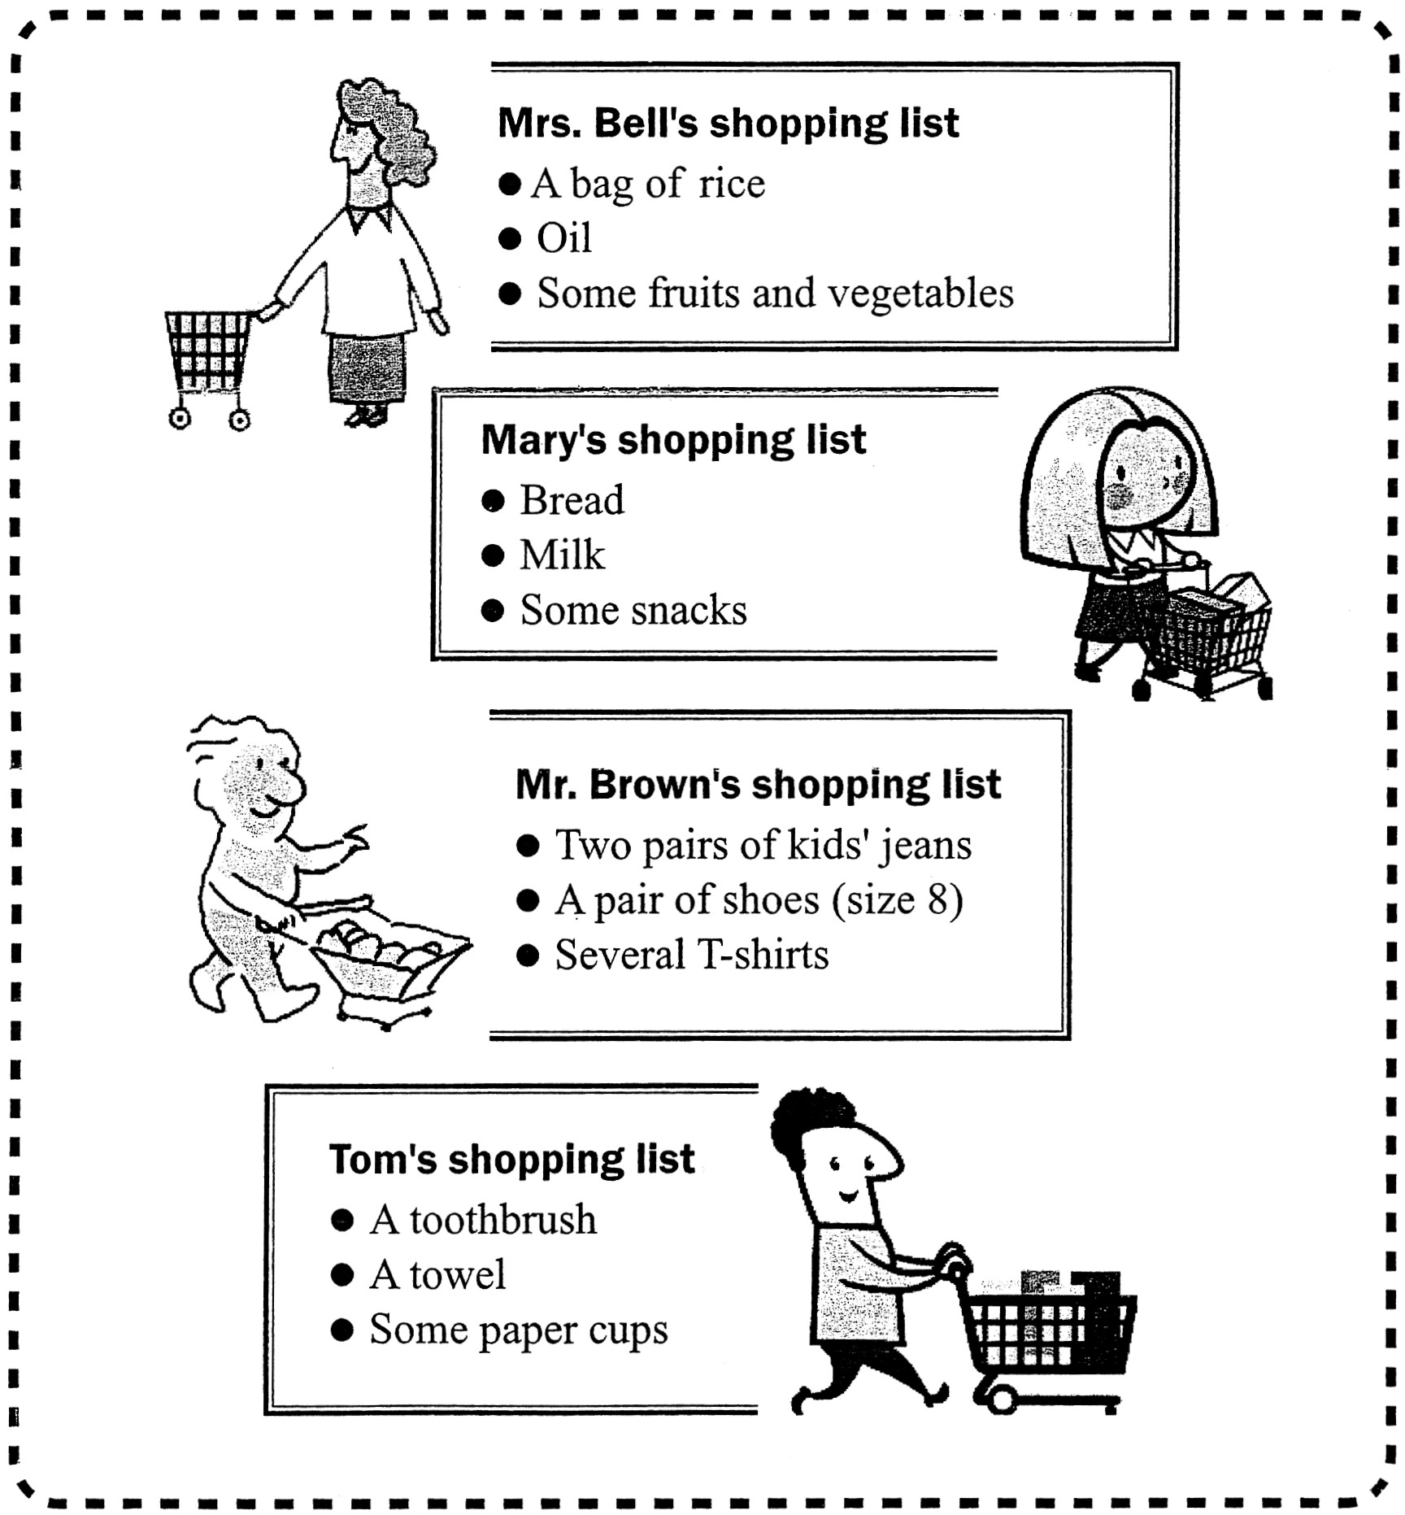

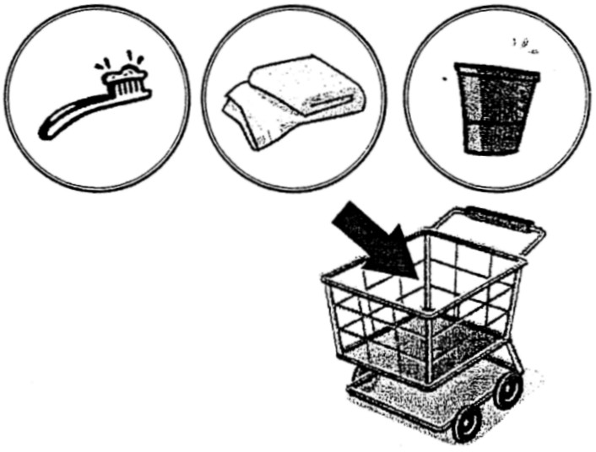

27. Whose shopping basket is this ?
(A) Mrs. Bell’s. (B) Mary’s. (C) Mr. Brown’s. (D) Tom’s.
28. Where will Mrs. Bell go to do the shopping ?
(A) The supermarket. (B) The bakery. (C) The hospital. (D) The gas station.
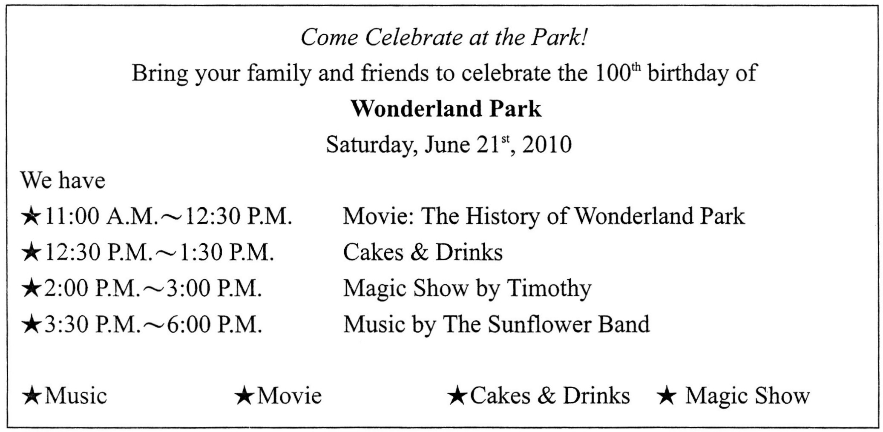
(29～30)

29. When was the Wonderland Park built ?
(A) In 2000. (B) In 1990. (C) In 1910. (D) In 1900.
30. Vicky called when Debby was watching Timothy’s magic show at the Wonderland Park. What time did Vicky call ?
(A) At half past three. (B) At a quarter to three. (C) At ten to two. (D) At a quarter past three.
※請接第二張※
三英語2
(31～33)
The Beijing-Shanghai High-Speed Railway, also known as the Jinghu High-Speed Railway is a 1,318 km long high-speed railway that runs between Beijing and Shanghai, stopping at 21 stations along the way. The building of this railway began on April 18, 2008; it will start operation in summer 2011, one year ahead of the original plan. Once in operation, its train will surpass the trains of the Wuhan-Guangzhou line, which are the world’s fastest, opening in December 2009. The trains of Jinghu line will be able to speed up to 380 km/h. Also, the non-stop train from Beijing to Shanghai can run at 329 km/h, cutting the train travel time from 10 hours to 4 hours.
The railway is said to cost about $32 billion. Around 220,000 people will be using the trains each day. During peak hours, trains will run every five minutes.
high-speed railway 高速鐵路 operation營運 original原先的 surpass超過 speed加速 billion十億 peak尖峰
31.When was the Jinghu High-Speed Railway thought to start running at first?
(A) In 2010. (B) In 2011. (C) In 2012. (D) In 2013.
32. How long does it take to travel from Beijing to Shanghai by train now ?
(A) 4 hours. (B) 6 hours. (C) 9 hours. (D) 10 hours.
33. Which is true ?
(A) The trains of Wuhan-Guangzhou line run between Beijing and Shanghai.
(B) Twenty-two million people will take the trains every day when the Jinghu line is finished.
(C) The trains of the Wuhan-Guangzhou line run fastest in China now.
(D) The trains of the Jinghu line will stop at only two stations, Beijing and Shanghai.
(34～36)
Dear Mr. Chapman,
Here is your order, The World in Pictures. We are very sorry it came three days late. This book has been very popular the past few months. As Ms. Gould died just last month, people want to remember her by keeping copies of her greatest pictures. To thank you for your wait, we are giving you a special coupon for 50% off your next order. You will find it just in front of page 1 in The World in Pictures
In the memory of Ms. Gould, we have made available all of her works from the past 50 years in a special collection. If you are interested, please go onto the Internet and see what we have. Once again, thank you so much for ordering from Pages & Pages and we hope that you will make good use of the coupon to continue your love of reading.
Yours,
Henry Campbell
coupon 減價優待券 available 可買到的 continue繼續 author作者
34.What is The World in Pictures？
(A) A CD. (B) A book. (C) A movie. (D) A store.
35. Why did Mr. Chapman’s order come late ?
(A) The order was too expensive. (B) The coupons will be given to readers next time.
(C) The coupons were not given out yet. (D) The author just died, and lots of people bought the book.
36. Which is correct ?
(A) Henry works for Pages & Pages.
(B) From now on, Mr. Chapman can buy book with 50% off.
(C) Henry sent a coupon to Mr. Chapman because people want to remember Ms. Gould.
(D) If Mr. Chapman is interested in any other books of Ms. Gould, he may go to the bookstore in his neighborhood.
(37～39)
Trip  Price | Ali Mountain  in Chiayi | Salt Mountain  in Tainan | Sun-moon Lake  in Nantou | Aowanda  in Nantou
Weekdays | NT$1,200 / adult  NT$1,000 / child | NT$ 900 / adult  NT$ 700 / child | NT$ 1,000 / adult  NT$ 800 / child | NT$ 1,100 / adult  NT$ 900 / child
Weekends  &  Holidays | NT$1,400 / adult  NT$1,200 / child | NT$1,100 / adult  NT$ 900 / child | NT$ 1,200 / adult  NT$ 1,000 / child | NT$ 1,300 / adult  NT$ 1,100 / child
1. Travelers start off from Taipei Train Station.
2. Price includes tickets to trip places and lunch.
3. Trips to Nantou include taking a hot spring bath.
4. Adults over seventy years old can get 30% off.
5. Children are those aged under twelve years old.
adult 成年人 extra額外地
※第二張，背面有試題※
三英語3
37. Mr. and Mrs. Li will go to Aowanda with their son, ten years old on Saturday. How much will they spend ?
(A) NT$ 3,100. (B) NT$ 3,400. (C) NT$ 3,700. (D) NT$ 4,000.
38. Mr. and Mrs. Chen will take their thirteen-year-old son and Mrs. Chen’s seventy-five-year-old mother on a trip to Sun-moon Lake next Wednesday. How much will they spend?
(A) NT$ 3,500. (B) NT$ 3,700. (C) NT$ 3,800. (D) NT$4,440.
39. Which of the following is true ?
(A) The old can take a trip for free.
(B) You can take a hot spring bath if you go to Mt. Ali.
(C) Weekday trips are two hundred dollars cheaper than holiday trips.
(D) People who go on one of the trips have to pay extra for lunch.
(40～41)
National Taiwan Science Education Center
Magic and Science Camp

Do you want to learn more about magic and science? Although you will not be walking around with a robe and a wand, you can still become a great wizard and learn how to turn a can into a dog or learn how to fly. Come join our Magic and Science camp, and you will find a different world!
- Magic Math Camp: March 13, March 27, April 10, April 24
9:00a.m. – 12:00p.m. Saturdays Only
- Magic Science Camp: March 13, March 27, April 10, April 24
1:30 p.m. – 4:30 p.m, Saturdays Only
＊To learn more and sign up, please visit www.ntsec.com.tw
education 教育 robe長袍 wand魔杖 wizard巫師 sign up報名登記 website網站
40. If Catherine wants to join the camp, what should she do ?
(A) Go on the Internet. (B) Make a phone call. (C) Write a letter. (D) Visit the education center.
41. Which is NOT true about the camp ?
(A) The camp will be held on weekends.
(B) You can take both the Science and Math classes.
(C) You have to buy yourself a robe and a wand in order to join the camp.
(D) Those who want to learn more may visit the website of the center.
(42～44)
Mom: Helen, Mr. Chen and his family will come to our house for dinner. Can you help me set the table?
Helen: Sure. What should I do ?
Mom: First, put each plate on the table. The spoon and the knife are on its right and the fork is on its left.
Helen: Where should I put the glass?
Mom: On the right side in front of the knife.
Helen: OK, Mom. Can you tell me some table manners?
Mom: No problem. Always dab your mouth with a napkin, which should be on your lap when not in use. Remember, dab your mouth only. Do not wipe your face or blow your nose with a napkin. Also, don’t talk with your mouth full of food.
Helen: What should I do I if I want the sugar far away from me ?
Mom: Ask someone who sits in front of the sugar to pass it to you. Don’t reach for it.
Helen: Oh, I see. Thank you, Mom.
napkin餐巾紙 dab輕擦 lap膝上 reach for伸手去拿 refer to意指
42. Which is correct ?
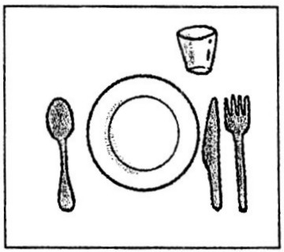
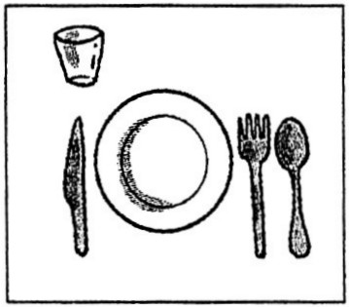
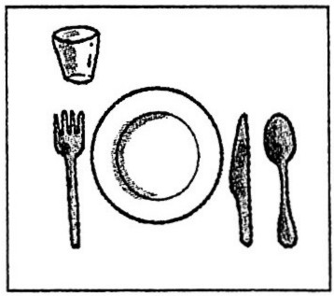
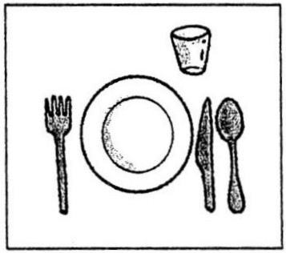
(A) (B) (C) (D)

43. What does its in line 4 refer to ?
(A) The knife. (B) The spoon. (C) The plate. (D) The table.
44. Which are NOT good table manners ?
(A) Put the napkin on the neck. (B) Dab your mouth with the napkin.
(C) No talking with your mouth full. (D) Ask someone to pass something to you.
※請接第三張※
三英語4
(45～47)

2011/02/20 2nd Kaohsiung International Marathon MIZUNO Cup


Date : 20th February 2011 (Sunday)
Time : 6:30am
Venue : National Stadium, Kaohsiung City, Taiwan
Distance and Entry Fee :
Distance | Entry Fee
Full Marathon - 42.195km | TWD700
Half Marathon - 23.1996km | TWD500
Challengers - 10.1338km | TWD300
Fun Run - 3.58km | Free
Roller Skating Marathon - 23.1996km | TWD500
Medal: Top 10 runners who complete the full and half-marathon will receive a medal
Certificate: Runners who complete the race will receive a completion certificate.
Race Kit Collection : 19th February 2011(Saturday), 9:00am – 6:00pm. A t-shirt and towel is given to all runners, except for fun runners. A mini towel is given to fun runners after the race.
Organizer: Bureau of Education and Department of Sports, Kaohsiung City Government
Contact: Department of Sports, Kaohsiung City
    - +886-7-7229494 +886-7-7229494 ext 712,713
    - +886-7-9735359 +886-7-9735359 ext 712,713
Website: http://www.twsport.org.tw/marathon or http://www.khms.gov.tw
Marathon馬拉松賽跑 venue集合地點 stadium運動場 distance 路程 entry fee參加費 challenger 挑戰者 medal獎章 complete完成 race 賽跑 certificate 證明書 except 把…除外 kit 運動成套裝備
organizer 主辦者 contact 聯絡
45. A half marathon runner had to .
(A) arrive at National Stadium by 6:30am. (B) pay TWD700.
(C) run about 10 km. (D) pick up his race kit 2 days ahead of the race.
46. The distance of half marathon is as long as that of .
(A) full marathon (B) challengers (C) fun run (D) roller skating marathon
47. Which is wrong ?
(A) Sam joined Fun Run, and he got a mini towel on Feb. 19th .
(B)The organizers are Bureau of Education and Department of Sports.
(C) Top 10 winners will get a completion certificate and a medal.
(D) If runners have any questions, they can make a phone call or go on the websites.
(48～50)
Student News
9th February 2011
Two of England’s top universities are thought to increase tuition fees to the highest level allowed by new laws. Both Oxford and Cambridge said that charging the highest for all subjects from 2012 was the only way of keeping academic excellence.
The cost of a top education in England is possibly to rise greatly. The British government chose to allow universities to increase tuition fees to $9,500 a year. Surprisingly, both of England’s most famous universities have already pointed out that they will charge this top rate. They both said they will charge poorer students less in some ways. However, some students said talented young people could still stop applying, to keep away from being overwhelmed by debt. They are afraid that social elitism will replace academic excellence.
Mark Brown, BCC News
university大學 increase增加 tuition fees學費 academic學術的 excellence卓越 government政府
talented 資質優異的 apply申請 overwhelm壓倒 debt負債 elitism菁英主義 replace取代 headline報紙標題
48. What are Oxford and Cambridge ?
(A) Two law schools. (B) Universities in England. (C) Heads of schools. (D) Not talked about.
49. Which is wrong about the news ?
(A) Both schools think that more tuition fees mean academic excellence.
(B) New laws allow universities to charge more.
(C) Poorer students won’t get any help from these two universities.
(D) Talented young people may not choose these two universities because they don’t want to get into heavy debt.
50. Which one is the headline of the news ?
(A) Top universities possibly to charge highest fees. (B) Top universities to charge poorer students less.
(C) Keeping academic excellence is important. (D) Social elitism will replace academic excellence.
※第三張※
三英語5

