一年 班 座號： 姓名：
※背面有試題※
一英語1
高雄市立陽明國中99學年度第2學期第2次段考一年級英語科試題
一、聽力測驗：20％
Part A：根據圖片和所聽到的敘述，相符者寫 "T"，不符者寫"F"（每題只唸一遍，請仔細聆聽後作答）。5％
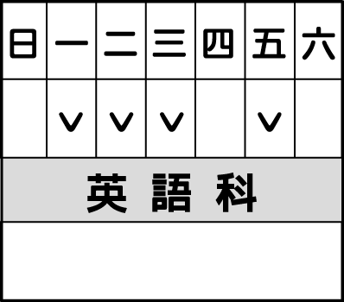
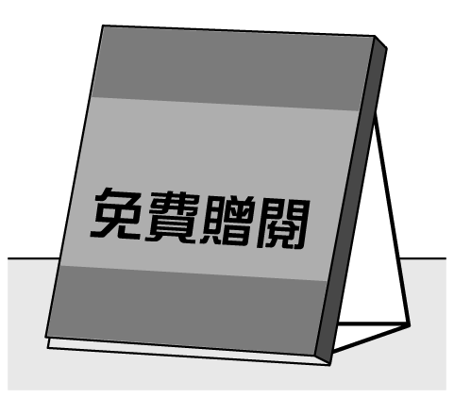
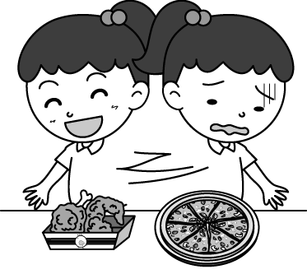
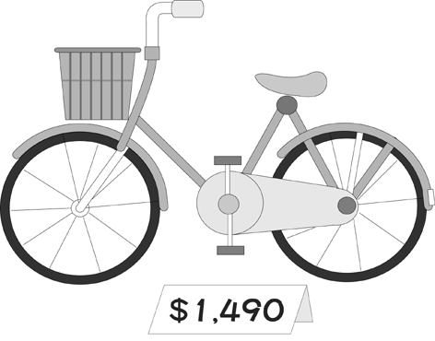
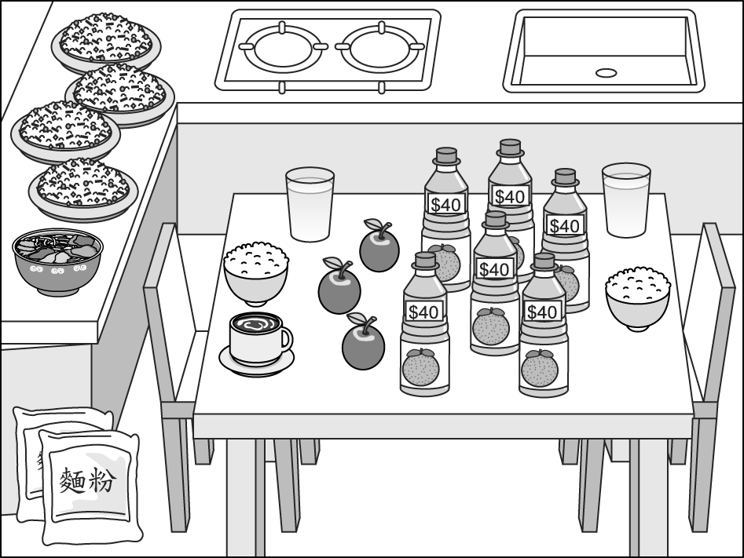

1.( ) 2.( ) 3.( ) 4.( ) 5.( )
Part B：根據所聽到的內容，選出適當的回應句（每題只唸一遍，請仔細聆聽後作答）。5％
1. (A) Where is your house? (B) Poor you! (C) Don’t say that again. (D) Come on in.
2. (A) Thank you. (B) Just wait and see. (C) That’s a good idea! (D) That’s all right.
3. (A) Too bad. (B) I can’t wait! (C) Not at all. (D) I hate it!
4. (A) No, it’s very hard. (B) Yes, it isn’t very hard. (C) No problem. (D) No. It’s very easy.
5. (A) Sure. (B) No, I can’t. (C) See you. (D) Tea is fine with me.
Part C：聽CD中的短文或對話，選出最適當的答案（每題均唸兩遍，請仔細聆聽後作答）。10％
1. (A) Eleven. (B) Seven. (C) From seven to eleven. (D) He’s very old.
2. (A) Once a week. (B) Twice a week. (C)Three times a week. (D) Four times a week.
3. (A) Yes, she is. (B) Yes, she does. (C) No, she isn’t. (D) No, she doesn’t.
4. (A) One. (B) Two. (C) Three. (D) Ten.
5. (A) $1000. (B) $850. (C) $600. (D) $250.
二、文意字彙：20％
____________1.Many kids like the stories in the book “One T d and One Nights.”
____________2.Monday is the s d day of the week.
____________3. The zookeeper is f ing a cute baby elephant now.
____________4.Mr. Brown s ls flowers on the corner of Yang Ming Road and Yi Hua Road every morning.
____________5. On Halloween(萬聖節), people use p ns to make jack-o’- lanterns(燈籠).
____________6. Dad: It’s 6:30 a.m. Get up, boys. The e y bird catches the worm(蟲).
Sons: But today is Sunday, Dad. Give us a break.
____________7. The handbag is $80,000. It’s really e e.
____________8. Joe: Where is my car key, Mom? Mom: In the right d r of your desk.
____________9. I go to the night m t once a week. I like the stinky tofu (臭豆腐) there very much.
____________10. Bubble tea(珍珠奶茶) is one of my favorite d ks.
三、文法選擇：20％
1. A: May I help you? B: I ________ some now.
(A) am needing ; apple and cake mix (B) am needing ; apples and cake mixes
(C) need ; apples and cake mix (D) need ; apples and cake mixes
2. A: plates of pizza ______ there on the table? B: Only one.
(A) How much ; is (B) How many ; are (C) How many ; is (D) How much ; are
3. _________ food do you have for our picnic? Five cans of _____ and one pack of _______.
(A) How many ; cokes ; cookies (B) How many ; coke ; cookie
(C) How much ; coke ; cookies (D) How much ; coke ; cookie
4. A:_____________ do they surf the Net? B: Three times a week.
(A) How often (B) How much time (C) How about (D) How long
5. A: Do you ever visit (參觀)Taipei International Flora Expo (台北花博)? B: No, ____________.
(A) I never (B) I do never (C) I never am (D) I never do
6. Angela ______ late for work, but her husband _________.
(A) is seldom ; is often (B) is seldom ; often is (C) seldom is ; often is (D) seldom is ; is often
7. _______Mr. Wang always busy___the end of the month?
(A) Does ; in (B) Does ; at (C) Is ; at (D) Is ; in
8.請選出正確的句子。
(A)What season do you like, summer or winter? (B) He flies a kite in the park sometimes.
(C) My teacher always can tell us interesting stories. (D) Joe hates bath.
9.請選出正確的句子。
(A) Which sport do you like, the basketball or the baseball?
(B) Johnny is sad in rainy days.
(C) There are many pigs in the farm.
(D) A: Do you need some coffee or juice? B: Juice, please.
10.請選出正確的句子。
(A) I get two hundreds fifty dollars from my parents every week. (B) The meat is enough for you and I.
(C) The bananas are on a sale. (D) The baby is still sleeping.
四、克漏字選擇：10％
(一)
Dear Diary: Monday, February 14th , 2011
Today is my third day in my new school. Everything 1. fine. I make 2. new friends. They are very nice 3. me. My homeroom teacher(導師) 4. a nice teacher. She teaches well and takes good care of the class. I am 5. to be here.
1. (A) is (B) does (C) are (D) can
2. (A) a lot (B) a lot of (C) lot of (D) much
3. (A) with (B) for (C) to (D) of
4. (A) also is (B) is also (C) too is (D) is too
5. (A) enough luck (B) luck enough (C) enough lucky (D) lucky enough
(二)
（Judy happens to meet（碰巧遇見）her classmate, Susan, in the department store (百貨公司).）
Judy : Hi, there. Are you buying something?
Susan : No, I am just looking around. 6. ?
Judy : Christmas is coming. I am looking for gifts 7. my family.
Susan : The department store is having a sale. Now it’s the right time to buy gifts.
Judy： 8. Look! The CDs over there are 50% off. They are so cheap. 9. , are you free now?
Susan : Yes! What’s up?
Judy：It’s 11:30. I am a little 10 . Let’s have lunch together.
6. (A) How about you (B) Are you OK (C)) Why not (D) How is it
7. (A) of (B) at (C) from (D) for
8. (A) You can say that again. (B) I have no idea. (C) What? (D) Let’s buy them.
9. (A) Of course (B) I see (C) By the way (D) Please
10. (A) full (B) hungry (C) dirty (D) fat
※請接第二張※
一英語2
五、閱讀測驗：6％
(1) Read the poster and answer the questions.

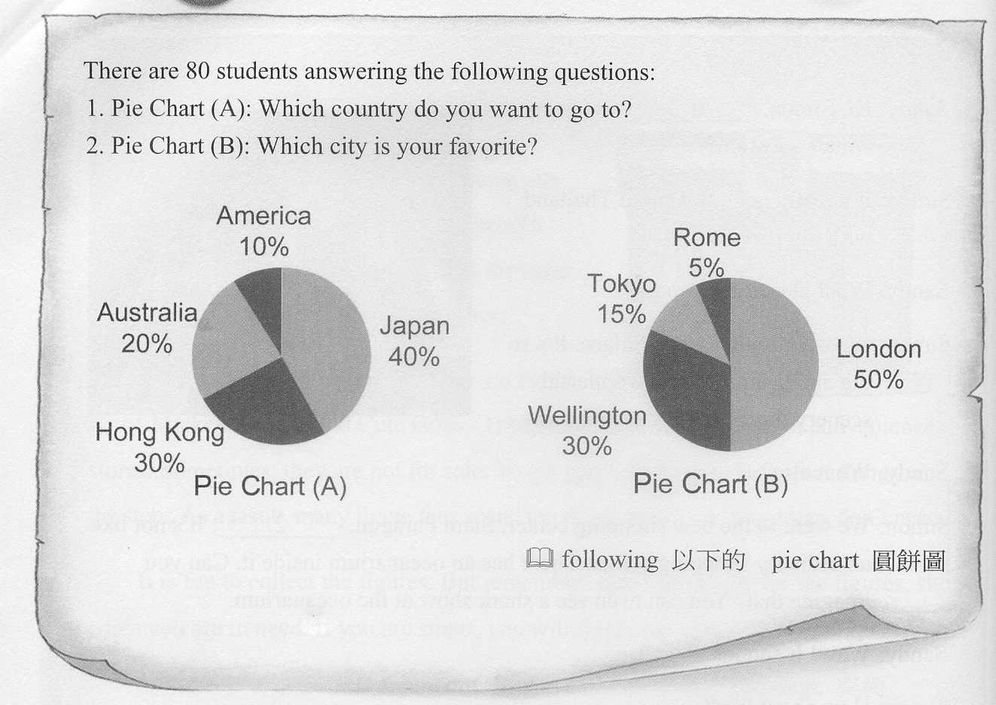
 city城市 country 國家 want想要
1. How many students want to go to America or Australia?
(A) 8 students. (B) 16 students. (C) 32 students. (D) 24 students.
2. Which is true about Pie Chart (A)?
(A) Only 10％ of the students want to go to America. (B) Sixteen students want to go to Hong Kong.
(C) Twenty students want to go to Australia. (D) Forty students want to go to Japan.
3.Which is not true about Pie Chart (B)?
(A) Four students like Rome. (B) London is forty students’ favorite city.
(C) Thirty students like Wellington. (D) Twelve students like Tokyo.
六、依提示作答：8％
1. These comic books are NT$ 180. (依劃線部分造原問句）
2. Paul plays tennis on weekends, but I don’t. （前句加入usually，後句加入seldom，再重寫整句）
3. My sister eats two meals a day. （依劃線部分造原問句）
4. The bus runs every fifteen minutes. （依劃線部分造原問句）
七、翻譯：16％ (第一題4分，第2～5題，每題3分)
1. A：你如何製作巧克力奶昔？
B：首先，將牛奶和巧克力冰淇淋放入果汁機，然後打一分鐘。
2. David的錢花到哪裡去了呢？他甚至買不起一瓶水。
3.在母親節前一天，我弟弟總是自己做一張卡片給媽媽。
4.我和這隻母牛是好朋友，我能騎在她背上。
5.你晚餐吃哪一樣，炸雞或一碗牛肉麵？
※第二張※
一英語3
高雄市立陽明國中99學年度第2學期第2次段考一年級英語科聽力腳本
一、聽力測驗：20％
Part A：根據圖片和所聽到的敘述，相符者寫 "T"，不符者寫"F"（每題只唸一遍，請仔細聆聽後作答）
1. The students have English class three times a week.
2. Good news! The books are free. Do you want me to get one for you？
3. The little girl likes fried chicken but hates pizza.
4. The bike is very cheap. It’s only one thousand five hundred and ninety dollars.
5. There are six bottles of orange juice on the table and they are forty dollars.
Part B：根據所聽到的內容，選出適當的回應句（每題只唸一遍，請仔細聆聽後作答）
1. I am already fifty years old but I don’t even have my own house.
2. It’s so hot today. Let’s have some ice cream.
3. You play computer games all day long. Aren’t you tired?
4. Isn’t Lesson Six very hard?
5. Can I have some tea?
Part C: 聽CD中的短文或對話，選出最適當的答案（每題均唸兩遍，請仔細聆聽後作答）。10％
For Q1 to Q3, please listen to the passage
Mrs. Smith has two sons, Sam and Ray. Sam is eleven years old and Ray, seven years old. The two boys often play sports after school. They play basketball on Monday and Thursday and play baseball on Friday. Mrs. Smith cooks dinner every day and usually goes to bed at midnight. She loves her sons very much.
Q1 : How old is Mrs. Smith’s first son?
Q2 : How often do Sam and Ray play sports?
Q3 : Does Mrs. Smith go to bed late? (Repeat.)
For Q4& Q5, please listen to the following dialogue:
Mother: This Sunday is Father’s birthday. I want to cook beef noodles and make some cookies for your father. I need to buy a lot of things at the market.
Daughter: How much beef do you need?
Mother: About ten pounds.
Daughter: Ten pounds! That’s a lot. And how about sugar and flour?
Mother: Let me see… I need one bag of sugar and three bags of flour.
Daughter: How much is the total?
Mother: The beef is about six hundred dollars. The sugar and flour are two hundred and fifty dollars.
Daughter: That’s great. I have $ 1000, my pocket money. I have enough money for it.
Mother: Oh, my good daughter!
Q4: How many pounds of beef does the mother need?
Q5: How much are the beef, sugar, and flour? (Repeat.)
一年 班 座號： 姓名：
高雄市立陽明國中99學年度第2學期第2次段考一年級英語科答案卷
訂正後分數 | 訂正教師簽名 | 閱卷分數
一、聽力測驗：20％
Part A：根據圖片和所聽到的敘述，相符者寫 "T"，不符者寫"F"（每題只唸一遍，請仔細聆聽後作答）5％
1. |  | 2. |  | 3. |  | 4. |  | 5.
Part B：根據所聽到的內容，選出適當的回應句（每題只唸一遍，請仔細聆聽後作答）5％
1. |  | 2. |  | 3. |  | 4. |  | 5.
Part C：聽CD中的短文或對話，選出最適當的答案（每題均唸兩遍，請仔細聆聽後作答）。10％
1. |  | 2. |  | 3. |  | 4. |  | 5.
二、文意字彙：20％
1. |  | 2. |  | 3. |  | 4. |  | 5.
6. |  | 7. |  | 8. |  | 9. |  | 10.
三、文法選擇：20％
1. |  | 2. |  | 3. |  | 4. |  | 5. |  | 6. |  | 7. |  | 8. |  | 9. |  | 10.
四、克漏字選擇：10％
1. |  | 2. |  | 3. |  | 4. |  | 5. |  | 6. |  | 7. |  | 8. |  | 9. |  | 10.
五、閱讀測驗：6％
1. |  | 2. |  | 3.
六、依提示作答：8％
1.
2.
3.
4.
七、翻譯：16％ (第一題4分，第2～5題，每題3分)
1. | A：
1. | B：
2.
3.
4.
5.

