二年 班 座號： 姓名：
高雄市立陽明國中99學年度第2學期第2次段考二年英語科試題
※背面有試題※
二英語1
一、聽力測驗：15％
(A)聽短文後，請將名字代號分別填入圖中 (每題1分)：5％ (短文唸二次)
(A) Andy (B) Betty (C) Jenny (D) Ken (E) Wendy
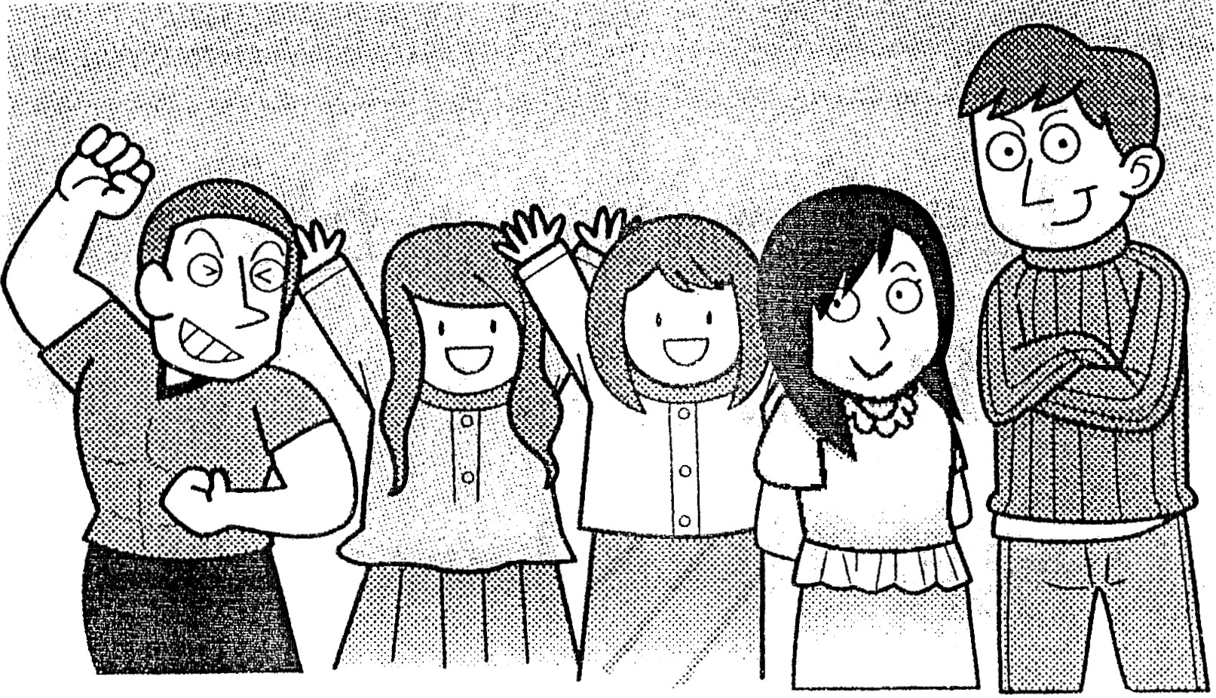

1. 2. 3. 4. 5.
(B)聽對話及問題後，請選出最適當的答案 (每題2分)：10％(每題均唸二次)
1. (A) The girl. (B) The boy. (C) Kelly. (D) We don’t know.
2. (A) He didn’t enjoy both of the movies. (B) He liked the two movies.
(C) He liked only one of the movies. (D) He liked interesting movies.
3. (A) She wants her son to finish his homework. (B) She wants her son to play more computer games.
(C) She wants her son to study harder. (D) She wants her son to be happy.
4. (A) The food in the restaurant is not delicious. (B) He doesn’t like the cook.
(C) The food is great but expensive. (D) The food is as cheap as before.
5. (A) They come from the rain forest of Taiwan. (B) They are beautiful. We can play with them.
(C) They are in danger because they have many colors. (D) It may not be safe to touch them.
二、文意字彙：20％(每題2分)
________________ 1. Eric always talks in class. He is the n t of all the students.
________________ 2. Tina acted well in the movie and won the best a s award (獎).
________________ 3. A：Can I take your order？
B：Not yet. All your food looks so delicious that I can’t make a d n.
________________ 4. A common（共同的）language is a b e between cultures (文化).
________________ 5.Paul c d eight boxes on his back before. He was as strong as an ox.
________________ 6. The kid likes to raise a h r. It’s a kind of mouse.
________________ 7. It’s d s to drive too fast on the road.
________________ 8. Keep trying and never give up, and your dream will come true（實現）in the f e .
________________ 9. Father is a h g man. He works even on weekends.
________________10. This bag is not from Taiwan. It is f n. No wonder it’s so expensive.
三、文法選擇：20％(每題2分)
1. Does of the boys have a cellphone？
(A) each (B) all (C) most (D) every
2. Jack is a student and he’s one of students in my class.
(A) worse；worse (B) worse；worst (C) bad；the worst (D) bad；worse
3. Terry broke his leg yesterday. His leg very much.
(A) hurted (B) was hurting (C) get hurt (D) hurt
4. of elementary school students want to keep pets.
(A) Many (B) Two hundred (C) A little (D) Hundreds
5. Ivy bought a car last week. She likes very much.
(A) one (B) another (C) it (D) the other
6. A：Which girl is your sister？ B： in a mini skirt.
(A) One (B) The one (C) The other (D) She
7. The library is than two years ago.
(A) more big and more beautiful (B) much bigger and more beautiful
(C) bigger and beautiful (D) more bigger and beautiful
8. My uncle, Allen, is .
(A) one foot taller than me. (B) one kilo taller than I.
(C) three years older than I do. (D) older two years than me.
9.選出正確的答案
(A) Several of the food in the store smells good.
(B) Half of the students take notes in class.
(C) My friend lives another side of the river.
(D) He had three birds. Both of them were dead. Now he takes care of the only one carefully.
10.選出正確的答案
(A) John agreed mopping the floor. (B) Tom is thinner than any boy in his class.
(C) Many of we are shyer. (D) We are grateful to our teacher for treating us well.
四、填入適當的形式(不限填一字)：14％(每題2分)
1. The rose is (red) of the two.
2. Mary’s brother is as (successful) as mine.
3. Aaron has (little) hair in his family.
4. All of the sheep (be) Mr. Black’s before.
5. All of the fruit (taste) sweet. Do you want to buy some？
6. Be polite to (other). Then you’ll become popular.
7. The pig eats food (hungry) and fast because the owner seldom feeds it.
五、閱讀測驗：10％(每題2分)
(A) 1～3
Take Care of Your Teeth！
There are some tips for taking care of your teeth.
＊Brush your teeth at least twice a day─If you can, brush them after breakfast, lunch, snacks, and before bedtime.
＊Take at least 3 minutes each time─Brush all of your teeth. You can’t just brush the front ones. You need to spend some time on the teeth along the sides and in the back.
＊Visit the 3. twice a year─They will help keep your teeth extra clean and teach you the best way to brush and floss your teeth.
Besides, you also need to be careful about what you eat and drink. Eat lots of fruit and vegetables and drink water instead of soda. Never forget to smile！
 tip 祕訣 front 前面的 extra 特別的 floss 以牙線清理
besides 此外 instead of 而不是 soda 汽水
※請接第二張※
二英語2
1.The best way to protect (保護) your teeth is .
(A) smiling (B) eating fruit and vegetables (C) drinking lots of soda (D) brushing them at least twice a day
2. How much time does it take at least to brush your teeth a day？
(A) Six minutes. (B) Two minutes. (C) Three minutes. (D) It doesn’t matter(關係重大).
3. Choose the best answer to fill in the blank (空格).
(A) dentist (B) secretary (C) lawyer (D) fisherman
(B) 4～5
They keep telling me：
Make the correct plan；
Think the correct way；
Ask the right question；
Follow the right way.
Are things as simple as black or white？
Can we really find in life any clear line？
I’m not happy with what they say；
I believe there is another way.
Listen to me！
Listen to me！
Can I have my own voice？
Can’t I tell my own stories？
I’ll know what I feel.
I’ll say what I think.
I’ll start my own trip.
Then I’ll make my own history.
By Harley M.
 follow 跟隨 simple 簡單的 line 線 chance 機會
4. What is the writer asking for？
(A) A safe way to take a trip. (B) A chance to go his own way.
(C) An idea for writing his stories. (D) A correct answer to his question.
5. What does black or white mean in the reading？
(A) Now or then. (B) Right or wrong. (C) Two broken lines. (D) The writer’s favorite colors.
六、依提示作答：6％ (每題2分)
1. No other nurses in the hospital are more beautiful than Alice. (用最高級改寫句子)
2. I had ninety dollars.
(以……most of……合併)
I spent eighty dollars on candy.
3. The geese are 100 kilos.
(The geese……以比較級合併句子)
The mice are 70 kilos.
七、翻譯：15％ (每題3分)
1.他們看起來幾乎一模一樣，但他們在某些方面是不一樣的。
2.有了他父母的支持，他決定當個勇敢的士兵。
3.你可以從一哩遠處看到很多鯨鯊在海裡。
4. Albert從馬上摔下來了。你最好不要騎馬。
5.這雙胞胎的其中一個比另一個擅長玩橋牌。
※第二張※
二英語3
高雄市陽明國民中學99學年度第二學期第二次段考二年級英語科聽力測驗

(A)聽短文後，請將名字代號分別填入圖中。
(短文唸二次)
Look at the picture. They are my new neighbors in Kaohsiung. My name is Jenny. The boy next to me is the tallest of all. He is Ken. The two girls behind me are Betty and Wendy. Wendy is more outgoing than Betty. Betty’s hair is longer than Wendy’s. The other boy in the picture is Andy. He exercises every day. He is stronger than Ken. All of my new friends are very kind.

(B)聽對話及問題後，請選出最適當的答案。
(每題均唸兩次)
1.
Boy: Who is that tall girl?
Girl: She is Kelly.
Boy: Is she the tallest girl in our school?
Girl: No, she’s not. I am.
Question: Who is the tallest girl in the school?

2.
Man: I went to see two movies yesterday.
Woman: Wow, what do you think about the
movies?
Man: One is interesting, and the other is sad. But I enjoyed both of them.
Woman: I see.
Question: What did the man mean?

3.
Mom: Paul, you spent four hours playing computer games!
Boy: Mom, I finished all of my homework. Playing computer games makes me happy.
Mom: Good, but you should spend more time on school subjects. Getting good grades is more important than playing computer games.
Boy: OK. I’ll turn off my computer.
Question: What does the boy’s mom want?

4.
Woman: Hi, I’m the cook. Do you like our new meal here?
Man: Yes. It tastes more delicious than before.
Woman: Thank you.
Man: Urr… but it’s also more expensive than before.
Question: What does the man mean?

5.
Woman: Look! These frogs are so different!
Man: Yes, they are not from Taiwan. They come from the rain forests.
Woman: They have many colors. So beautiful!
Man: But beautiful frogs may be dangerous.
Woman: Really?
Man: Yes. You’d better not touch them.
Question：Which is true about the frogs?

本次聽力測驗結束

二年 班 座號： 姓名：
高雄市立陽明國中99學年度第2學期第2次段考二年級英語科答案卷
訂正後分數 | 訂正教師簽名 | 閱卷分數
一、聽力測驗：15％
(A)聽短文後，請將名字代號分別填入圖中 (每題1分)：5％
1 |  | 2 |  | 3 |  | 4 |  | 5
(B)聽對話及問題後，請選出最適當的答案 (每題2分)：10％
1 |  | 2 |  | 3 |  | 4 |  | 5
二、文意字彙：20％(每題2分)
1 |  | 2 |  | 3 |  | 4 |  | 5
6 |  | 7 |  | 8 |  | 9 |  | 10
三、文法選擇：20％(每題2分)
1 |  | 2 |  | 3 |  | 4 |  | 5 |  | 6 |  | 7 |  | 8 |  | 9 |  | 10
四、填入適當的形式(不限填一字)：14％(每題2分)
1 |  | 2 |  | 3 |  | 4 |  | 5
6 |  | 7
五、閱讀測驗：10％(每題2分)
1 |  | 2 |  | 3 |  | 4 |  | 5
六、依提示作答：6％ (每題2分)
1
2
3
七、翻譯：15％ (每題3分)
1
2
3
4
5

