二年 班 座號： 姓名：
高雄市立陽明國中99學年度第2學期第3次段考二年級英語科試題
Ⅰ、聽力測驗：20％
一、是非題：5％(每題1分)
1. |  | 2. |  | 3. |  | 4. |  | 5.
二、配合題：5％(每題1分)
(A) (B) (C) (D) (E) (F)
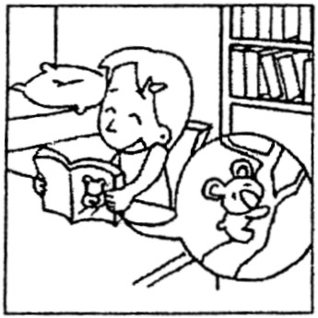
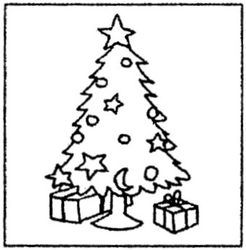
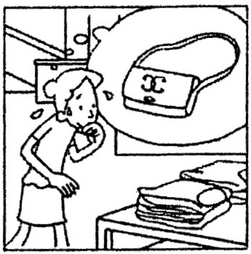
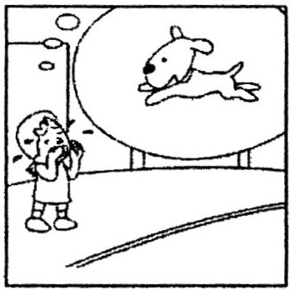
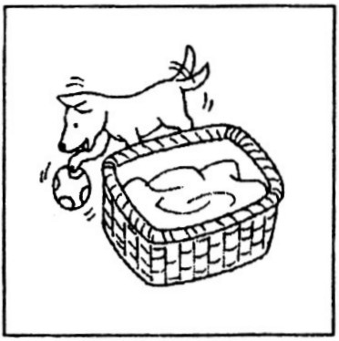
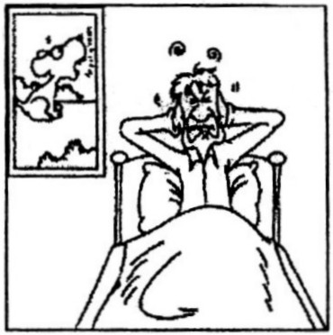

1. |  | 2. |  | 3. |  | 4. |  | 5.
三、選擇題：10％(每題2分)
1.( ) (A) Watching the movie. (B) Playing the computer game.
(C) Doing the homework. (D) Playing basketball.
2.( ) (A) The housework. (B) The dishes.
(C) The math homework. (D) The history homework.
3.( ) (A) No, not yet. (B) Yes, he has.
4.( ) (A) Yes, she does. (B) No, she doesn’t.
5.( ) (A) Listening to Jolin singing on the radio. (B) Playing with his brother.
(C) Playing bridge with his mom. (D) Watching Jolin dancing on TV.
Ⅱ、讀寫部分：80％
一、文意字彙：20％(每題2分)
________________ 1. The dog d g a hole in the garden to hide the bone.（骨頭）
________________ 2. The sky is g y, and it looks like rain.
________________ 3. Prince William and Katt Middleton had their r l wedding（婚禮）on April 29, 2011.
________________ 4. I got up late because the alarm c k didn’t work.
________________ 5. A real friend will support you and always stand by your s e.
________________ 6. The strong wind broke the window, so we have to clean up the p s.
________________ 7. When a typhoon hits, we should prepare some things, such as（比如）water, food, and
f s.
________________ 8.Mom cut her finger when cooking, and it b d.
________________ 9. Pay a n to your teacher, or you won’t be able to finish your exercises.
________________10. I’d like to have an apartment with a b y and I can grow many flowers in it.
二、文法選擇：20％(每題2分)
1.( ) There so many good times since I Yang-ming Junior High.
(A) are , enter (B) were , was entering (C) had , entered (D) have been , entered
2.( ) up early, or you will miss the first bus.
(A) To get (B) Get (C) Getting (D) By getting
3.( ) I’ll show you the pictures when I back to Taiwan.
(A) went (B) will go (C) go (D) am going
※背面有試題※
二英語1
4.( ) A woman has collected bottles and plastic bags.
(A) many hundreds (B) many hundred of (C) many of hundred (D) many hundreds of
5.( ) Here .
(A) are we (B) is John (C) the teacher comes (D) some caps are.
6.( ) I to Canada three times last year.
(A) went (B) have been (C) go (D) had been
7.( ) He is busy, so he able to go to the movie this evening.
(A) maybe not (B) may be not (C) may not be (D) may isn’t
8.( ) Teenagers enjoy in the mirror.
(A) look at yourselves (B) looking at themselves (C) to look at themselves (D) looked at yourself
9.( ) Our teacher asked us our classroom .
(A) keep , cleanly (B) to keep , cleanly (C) to keep , clean (D) keep , clean
10.( ) We heard Pete loudly in his room.
(A) cried (B) to cry (C) is crying (D) cry
三、克漏字選擇：10％(每題1分)
(A)
Dear Sara,
How (1) you (1)？ I (2) Japan for two months, and I (3) some new friends already. We go to the same language school, but come from different countries. I get used to my new life here.
Last weekend, I (4) to a street market and (4) some ramen with my friends. Though I
(5) some Japanese dishes so far, I like ramen best.
I hope so much to hear from you soon.
Best wishes
Jenny.
1.( ) (A) do , do (B) are , going (C) have , been (D) did , do
2.( ) (A) have been to (B) have been in (C) have gone to (D) am
3.( ) (A) made (B) make (C) am making (D) have made
4.( ) (A) went , had (B) have been , had (C) do , have (D) went , have
5.( ) (A) taste (B) have tasted (C) tasted (D) will taste
(B)
Mayday is one of the best bands in Taiwan. They (6) concerts and (6) many CDs so far. The band is very (7) teenagers, and it (8) the best group of the year last year.
“We are happy and grateful to our fans,” says the leading singer, A-hsien. “We really hope to push
(9) to play much more great songs for all of you. Most of all, we need you (10) us and (10) with us all the time.”
6.( ) (A) have , make (B) have had , made (C) will have , make (D) is having , making
7.( ) (A) popular with (B) crazy about (C) careful about (D) glad for
8.( ) (A) has won (B) won (C) will win (D) wins
9.( ) (A) yourselves (B) myself (C) ourselves (D) themselves
10.( ) (A) support , be (B) supporting , being (C) supported , was (D) to support , to be
※請接第二張※
二英語2
四、閱讀測驗：5％(每題1分)
A.（1～3）
Dear Mom,
I’m sorry that I had a fight with you last night. You are right. I shouldn’t spend too much time playing on-line games. I promise that I won’t get online for more than thirty minutes a day and I will study much harder than before.
David
Dear son,
I can’t remember how many times you promise me. I really want to believe you, but you seldom keep your promises. So I decided to solve this problem in my own way. I already gave your computer to a nursery school in our neighborhood. They wanted me to say“thank you”to you. You should feel happy about that because you did something good for other people in this way.
Your mom
 nursery school育院
1.( ) Why did David’s mom donate(捐贈) the computer to a nursery school？
(A) Because the computer couldn’t work.
(B) Because David felt sorry for the children in the nursery.
(C) Because David’s mom bought a new one for David.
(D) Because David’s mom didn’t want him to play computer games.
2.( ) Why did David write the note to his mom？
(A) He wanted to ask for a new computer.
(B) He wanted to say sorry to his mom.
(C) He wanted to give his computer to someone else.
(D) He wanted to help the children in the nursery school
3.( ) If you were David’s friend, what lesson(教誨) would you give him？
(A) Easy come, easy go (B) The more, the better.
(C) Keeping your promises is the most important of all. (D) It’s never too old to learn.
B.（4～5）
How to Take Care of Wild Bird Eggs
Steps：
1. Find an egg on the ground.
2. Keep it at about 100℉ in an incubator.
3. Turn the egg around a few times daily and wait for the egg to hatch.
4. Feed the bird often. Once the bird gets bigger and has all of the feathers, it usually can start to take very small pieces of bread on a toothpick.
Tips and warnings：
‧You have to learn what kind of bird it is to know the foods it eats. You might need to look for more information from or on some websites.
‧Do not take an egg from the nest.
‧Don’t ever turn off the incubator／light.
 incubator孵卵器；hatch孵化；feather羽毛；toothpick牙籤；warning警告
※第二張，背面有試題※
二英語3
4.( ) What can we learn from the passage（文章）？
(A) It’s not right to get the egg from the nest.
(B) Eggs can’t be found on the ground.
(C) We don’t have to keep the egg warm all the time.
(D) Birds can eat anything when they have all the feathers.
5.( ) Why should we learn about what kind of bird we feed？
(A) Birds can fly away easily.
(B) Different birds need different foods.
(C) Some birds don’t need any food.
(D) Some birds die because they eat too much.
五、改寫句子：10％(每題2分)
1. I had my dinner, but my brother didn’t.（改為完成式）
2. It’s ten years since I lived in Kaohsiung.（改為I……for……）
｛
3. The car has five doors.
（用……of……合併為一句）
They are dirty.
4. Sam learned English when he was a little child.（將when改為since）
5. The old man was poor, but he was happy.（改為Though……）
六、翻譯：15％(每題3分)
1.我們清理完沙灘之後，將沒有垃圾會進入海裡去傷害海裡的動物。（No……）
2.溫莎城堡是個參觀的好地方，所以你不應該錯過它。（……it.）
3.颱風來襲時務必要留在家裡並將花盆移至室內。（Be……）
4.我看見了外面下起了大雨，刮起了大風。
5.在台灣，我們每年夏天經歷數個颱風，所以我們必須在颱風前自我做好準備。（We……）
二英語4
二年 班 座號： 姓名：
高雄市立陽明國中99學年度第2學期第3次段考二年級英語科答案卷
訂正後分數 | 訂正教師簽名 | 閱卷分數
Ⅰ、聽力測驗：20％
一、是非題：5％(每題1分)
1. |  | 2. |  | 3. |  | 4. |  | 5.
二、配合題：5％(每題1分)
1. |  | 2. |  | 3. |  | 4. |  | 5.
三、選擇題：10％(每題2分)
1. |  | 2. |  | 3. |  | 4. |  | 5.
Ⅱ、讀寫部分：80％
一、文意字彙：20％(每題2分)
1. |  | 2. |  | 3. |  | 4. |  | 5.
6. |  | 7. |  | 8. |  | 9. |  | 10.
二、文法選擇：20％(每題2分)
1. |  | 2. |  | 3. |  | 4. |  | 5. |  | 6. |  | 7. |  | 8. |  | 9. |  | 10.
三、克漏字選擇：10％(每題1分)
1. |  | 2. |  | 3. |  | 4. |  | 5. |  | 6. |  | 7. |  | 8. |  | 9. |  | 10.
四、閱讀測驗：5％(每題1分)
1. |  | 2. |  | 3. |  | 4. |  | 5.
五、改寫句子：10％(每題2分)
1.
2.
3.
4.
5.
六、翻譯：15％(每題3分)
1.
2.
3.
4.
5.

